USING NEURAL NETWORKS TO FORECAST FLOOD EVENTS:

A PROOF OF CONCEPT

By
Ward S. Huffman

A DISSERTATION

Submitted to the
H. Wayne Huizenga School of Business and
Entrepreneurship
Nova Southeastern University

In partial fulfillment of the requirements
for the degree of

DOCTOR OF BUSINESS ADMINISTRATION

2007
A Dissertation
Entitled

USING NEURAL NETWORKS TO FORECAST FLOOD EVENTS:
A PROOF OF CONCEPT

By

Ward S. Huffman

We hereby certify that this Dissertation submitted by Ward S. Huffman conforms to acceptable standards and as such is fully adequate in scope and quality. It is therefore approved as the fulfillment of the Dissertation requirements for the degree of Doctor of Business Administration

Approved:

A. Kader Mazouz, PhD Date
Chairperson

Edward Pierce, PhD Date
Committee Member

Pedro F. Pellet, PhD Date
Committee Member

Russell Abratt, PhD Date
Associate Dean of Internal Affairs

J. Preston Jones, D.B.A. Date
Executive Associate Dean, H. Wayne Huizenga School of Business and Entrepreneurship

Nova Southeastern University
2007
CERTIFICATION STATEMENT

I hereby certify that this paper constitutes my own product. Where the language of others is set forth, quotation marks so indicate, and appropriate credit is given where I have used the language, ideas, expressions, or writings of another.

Signed ______________________
Ward S. Huffman

ABSTRACT

USING NEURAL NETWORKS TO FORECAST FLOOD EVENTS:
A PROOF OF CONCEPT

By

Ward S. Huffman

For the entire period of recorded time, floods have been a major cause of loss of life and property. Methods of prediction and mitigation range from human observers to sophisticated surveys and statistical analysis of climatic data. In the last few years, researchers have applied computer programs called Neural Networks or Artificial Neural Networks to a variety of uses ranging from medical to financial. The purpose of the study was to demonstrate that Neural Networks can be successfully applied to flood forecasting.

The river system chosen for the research was the Big Thompson River, located in North-central Colorado, United States of America. The Big Thompson River is a snow melt controlled river that runs through a steep, narrow canyon. In 1976, the canyon was the site of a devastating flood that killed 145 people and resulted in millions of dollars of damage.

Using publicly available climatic and stream flow data and a Ward Systems Neural Network, the study resulted in prediction accuracy of greater than 97% in +/-100 cubic feet per minute range. The average error of the predictions was less than 16 cubic feet per minute.

To further validate the model’s predictive capability, a multiple regression analysis was done on the same data. The Neural Network’s predictions exceeded those of the multiple regression analysis by significant margins in all measurement criteria. The work indicates the utility of using Neural Networks for flood forecasting.

ACKNOWLEDGEMENTS

I would like to acknowledge Dr. A. Kader Mazouz for his knowledge and support in making this dissertation a reality. As my dissertation chair, he continually reassured me that I was capable of completing my dissertation in a way that would bring credit to Nova Southeastern University and to me.
I would also like to acknowledge my father, whose comments, during my youth, gave me the continuing motivation to strive for and achieve this terminal degree.
I want to thank my wife and family, who supported me during very difficult times. I would definitely thank Mr. Jack Mumey for his continual prodding, support, and advice that were invaluable throughout this research.
The author would also like to recognize Nova Southeastern University for providing the outstanding professors and curriculum that led to this dissertation. Additionally, I appreciate the continued support from Regis University and the University of Phoenix that has been invaluable.

Table of Contents

Page

List of Tables……………………………………………………………………………………………………… vii

List of Figures…………………………………………………………………………………………………… viii

Chapter 1: Introduction……………………………………………………………………………… 1
Background…………………………………………………………………………………………………… 1

Chapter 2: Review of Literature………………………………………………………… 8
Neural Networks……………………………………………………………………………………… 8
Existing Flood Forecasting Methods…………………………………… 19

Chapter 3: Methodology………………………………………………………………………………… 23
Hypothesis…………………………………………………………………………………………………… 23
Statement of Hypothesis………………………………………………………………… 23
Neural Network………………………………………………………………………………………… 29
Definitions………………………………………………………………………………………………… 33
Ward Systems Neural Shell Predictor………………………………… 35
Methods of Statistical Validation……………………………………… 37

Chapter 4: Analysis and Presentation of Findings…………… 41
Evaluation of Model Reliability…………………………………………… 41
Big Thompson River……………………………………………………………………………… 43
Modeling Procedure……………………………………………………………………………… 46
Procedure followed in developing the Model……………… 49
Initial Run Results…………………………………………………………………………… 51
Second Run Results……………………………………………………………………………… 56
Final Run Results………………………………………………………………………………… 62
Multi-linear Regression Model………………………………………………… 70

Chapter 5: Summary and Conclusions………………………………………………… 72
Summary…………………………………………………………………………………………………………… 72
Conclusions………………………………………………………………………………………………… 72
Limitations of the Model……………………………………………………………… 75
Recommendations for Future Research………………………………… 76

Appendix
A. MULTI-LINEAR REGRESSION, BIG THOMPSON RIVER
DRAKE MEASURING STATION……………………………………………………… 80
B. MULTI-LINEAR REGRESSION MODEL, THE BIG
THOMPSON RIVER, LOVELAND MEASURING STATION…… 84

Data Sources…………………………………………………………………………………………………………… 88

References………………………………………………………………………………………………………………… 89

List of Tables

Table Page

1. Steps in Using the Neural Shell Predictor………………… 50

2. Summary of Statistical Results……………………………………………… 71
3. Model Summary-Drake…………………………………………………………………………… 81
4. Drake Coefficients……………………………………………………………………………… 82
5. Drake Coefficients Summary………………………………………………………… 83
6. Loveland Summary…………………………………………………………………………………… 85
7. Loveland Coefficients……………………………………………………………………… 86
8. Loveland Coefficients Summary………………………………………………… 87

LIST OF FIGURES

Figure Page

- USGS Map, Drake Measuring Station…………………………………………… 26
- USGS Map, Loveland Measuring Station…………………………………… 27
- Neural Network Diagram………………………………………………………………………… 31
- Map, Big Thompson Watershed…………………………………………………………… 45
- Map, Topography of the Big Thompson Canyon…………………… 46
- Drake, Initial Run, Actual vs. Predicted Values……… 52
- Loveland, Initial Run, Actual vs. Predicted Values 52
- Drake, Initial Run, R-Squared…………………………………………… ………… 53
- Loveland, Initial Run, R-Squared ………………………………… ………… 53
- Drake, Initial Run, Average Error ……………………………… ………… 54
- Loveland, Initial Run, Average Error Neuron……… ………… 54
- Drake, Initial Run, Correlation………………………………………………… 55
- Loveland, Initial Run, Correlation………………………………………… 55
- Drake, Initial Run, Percent-in-Range………………………… ………… 56
- Loveland, Initial Run, Percent-in-Range………………… ………… 56
- Drake, Second Run, Actual vs. Predicted………………… ………… 57
- Loveland, Second Run, Actual vs. Predicted………… ………… 57
- Drake, Second Run, R-Squared……………………………………………… ………… 58
- Loveland, Second Run, R-Squared………………………………………………… 58
- Drake, Second Run, Average Error…………………………………… ………… 59
- Loveland, Second Run, Average Error…………………………… ………… 59
- Drake, Second Run, Correlation………………………………………… ………… 60
- Loveland, Second Run, Correlation…………………………………………… 61
- Drake, Second Run, Percent-in-Range…………………………… ………… 61
- Loveland, Second Run, Percent-in-Range…………………… ………… 62
- Drake, Final Model, Actual vs. Predicted……………… ………… 63
- Loveland, Final Model, Actual vs. Predicted……… ………… 63
- Drake, Final Model, R-Squared…………………………………………… ………… 64
- Loveland, Final Model, R-Squared…………………………………… ………… 64
- Drake, Final Model, Average Error………………………………… ………… 65
- Loveland, Final Model, Average Error………………………… ………… 66
- Drake, Final Model, Correlation……………………………………… ………… 66
- Loveland, Final Model, Correlation……………………………… ………… 67
- Drake, Final Model, Mean Squared Error…………………… ………… 67
- Loveland, Final Model, Mean Squared Error…………… ………… 68
- Drake, Final Model, RMSE…………………………………………………………………… 68
- Loveland, Final Model, RMSE…………………………………………………………… 69
- Drake, Final Model, Percent-in-Range………………………… ………… 69
- Loveland, Final Model, Percent-in-Range………………… ………… 70

Chapter 1: Introduction

Background
One of the major problems in flood disaster response is that floodplain data are out of date almost as soon as the surveyors have put away their transits. Watersheds and floodplains are living entities that are constantly changing. The very newest floodplain maps were developed around 1985, with some of the maps dating back to the 1950s. Since the time of the surveys, the watershed’s floodplains have changed, sometimes drastically. Every time a new road is cut, a culvert or bridge is built, new or changed flood control measures or a change in land use occurs, the floodplain is altered. These inaccuracies are borne out in Federal Emergency Management Agency (FEMA) statistics that show that more than 25% of flood damage occurs at elevations above the 100-year floodplain (Agency, 2003). The discrepancies make planning for disasters and logistical response to disasters a very difficult task.
In an interview with the FEMA Assistant Director of Disaster Mitigation, (Baker, 2001) noted that these discrepancies also complicate the problems of the logistic planner. Three times in Tremble, Ohio, floods inundated much of the town during one 18-month period. The flooding included the only fire station. The depths of the

waterlines on the firehouse wall were three feet, four and a half feet, and ten feet. The 100-year flood plain maps clearly show that the fire station is not in the flood plain. The fact was no help to the community during the process of planning and building the fire station or during the flooding events and subsequent recovery when they had no fire protection.
FEMA field agent, stated that in Denver, Colorado, many of the underpasses on Interstate 25 were subject to flooding during moderate or heavy rains (Ramsey, 2003),. The flooding was not because of poor planning or construction. It was due to the change in land use adjacent to the interstate’s right of way. During planning and construction, much of the land was rural, agricultural, or natural vegetation. Since construction, the land has been converted to urban streets, parking lots, and other non-absorbent soil covers resulting in much higher rates of storm water runoff.
What is needed in flood forecasting is a system that can be continuously updated without the costly and laborious resurveying that is the norm in floodplain delineation. An example of such a process is the Lumped Based Basin Model. It is a traditional model that assumes each sub-basin within a watershed can be represented by a number of hydrologic parameters. The parameters are a weighted average representation of the entire sub-basin. The main hydrologic ingredients for this analysis are precipitation, depth, and temporal distribution. Various geometric parameters such as length, slope, area, centroid location, soil types, land use, and absorbency are also incorporated. All of the ingredients are required for the traditional lumped based model to be developed (Johnson, Yung, Nixon, & Legates, 2002).
The raw data is then manually processed by a hydrologist to produce the information needed in a format appropriate for the software. The software consists of a series of manually generated algorithms that are created by a process of trial and error to approximate the dynamics of the floodplain.
Even current models that rely on linear regression require extensive data cleaning, which is time and data intensive. A new model must be created every time there is a change in the river basin. The process is time, labor, and, data intensive; and, as a result, it is extremely costly. What is needed is a method or model that will do all of the calculations quickly, accurately, using data that requires minimal cleaning, and at a minimal cost. The new model should also be self-updating to take into account all of the changes occurring in the river basin.
Creating the new model was the focus of this dissertation. The model used climatic data available via telemetry from existing climatic data collection stations to produce accurate water flows in cubic feet per second.
In recent years, many published papers have shown the results of research on Neural Networks (NN) and their applications in solving problems of control, prediction, and classification in industry, environmental sciences, and meteorology (French, Krajewski, & Cuykendall, 1992; McCann, 1992); (Boznar, M., & Mlakar, 1993); (Jin, Gupta, & Nikiforuk, 1994); (Aussem, Murtagh, & M., 1995); (Blankert, 1994); (Ekert, Cattani, & Ambuhl, 1996); (Marzban & Stumpf, 1996)). Computing methods for transportation management systems are being developed in response to mandates by the U.S. Congress. The mandate sets forth the requirements of implementing the six transportation management systems that Congress required in the 1991 ISTEA Bill. Probably all the management systems will be implemented with the help of analytical models realized in microcomputers (Wang & Zaniewski, 1995).
While NNs are being applied to a wide range of uses, the author was unable to identify applications in the direct management of floodplains, floodplain maps, or other disaster response programs. The closest application is a study done to model rainfall-runoff processes (Hsu, Gupta, & Sorooshian, 1995).
It appears that most currently practiced applications of Geographic Information Systems (GIS) and Expert Systems (ES) rely on floodplain data that is seriously out of date. Even those few areas where new data is being researched and used still suffer from increasing obsolescence because of the dynamic characteristics of floodplains. With a program, a watershed and its associated floodplains can be updated constantly using historical data and real-time data collection from existing and future rain gauges, flow meters, and depth gauges. A model that allows constant updating will result in floodplain maps that are current and accurate at all times.
With such a model, real-time floodplains based on current and forecast rainfall can be produced. The floodplains could be overlaid with transportation routes and systems, fire and emergency response routes, and evacuation routes. With real flood impact areas delineated, an ES system can access telephone numbers of residences, businesses, governmental bodies, and emergency response agencies. The ES can then place automated warning and alert calls to all affected people, businesses, and government agencies.
With such a system, “false” warnings and alerts would be minimized, thus, reducing the “crying wolf” syndrome of emergency warning systems. The syndrome occurs often when warnings are broadcast to broad segments of the population, and only a few individuals are actually affected. After several of these “false” warnings, the public starts to ignore all warnings—even those that could directly affect them. The ES would also allow for sequential warnings, if the disaster allows, so that evacuation routes would not become completely jammed and unusable.
Another problem with published floodplains is that they depict only the 100-year flood. This flood has a 1% probability of happening in any given year. While this is useful for general purposes, it may not be satisfactory for a business or a community that is planning to build a medical facility for non-ambulatory patients. For a facility of this nature, a flood probability of .1% may not be acceptable. The opposite situation is true for the planning of a green belt, golf course, or athletic fields. In this situation, a flood probability of 10% may be perfectly acceptable.
Short of relying on out-dated FEMA floodplain maps or incurring the huge expense of mapping a floodplain using stick and transit survey techniques and a team of hydrologists, there is no way that an anyone can ascertain the floodplain in specified locations. Innovative techniques in computer programming such as genetic algorithms and NNs are being increasingly used in environmental engineering, community, and corporate planning. These programs have the ability to model systems that are extremely complex in nature and function. This is especially true of systems whose inner workings are relatively unknown. These systems can use and optimize a large number of inputs, recognize patterns, and forecast results. NNs can be used with out a great deal of system knowledge and that would seem to make them ideal for determining flooding in a complex river system.
This paper is an effort to demonstrate the potential use, by a layperson, of a commercially available NN to predict stream flow and probability of flooding in a specific area. In addition, a comparison was made between a NN model and a multiple-linear regression model.

Chapter 2: Review of Literature

Neural Networks
Throughout the literature the terms NN and ANN (Artificial Neural Network) are used interchangeably. They both refer to an artificial (manmade) computer program. The term NN is used in this dissertation to represent both the NN and ANN programs.
The concept of NNs dates back to the third and fourth Century B.C. with Plato and Aristotle, who formulated theoretical explanations of the brain and thinking processes. Descartes added to the understanding of mental processes. W. S. McCulloch and W. A. Pitts (1943) were the first modern theorists to publish the fundamentals of neural computing. This research initiated considerable interest and work on NNs (McCulloch & Pitts, 1943). During the mid to late twentieth century, research into the development and applications of s accelerated dramatically with several thousand papers on neural modeling being published (Kohonen, 1988).
The development of the back-propagation algorithm was critical to future developments of NN techniques. The method, which was developed by several researchers independently, works by adjusting the weights connecting the units in successive layers.
(Muller & Reinhardt, 1990) wrote one of the earliest books on NNs. The document provided basic explanations and focus on NN modeling (Muller & Reinhardt, 1990). Hertz, Krogh, and Palmer (1991) presented an analysis of the theoretical aspects of NNs (Hertz, Krogh, & Palmer, 1991).
In recent years, a great deal of work has been done in applying NNs to water resources research. Capodaglio et al (1991) used NNs to forecast sludge bulking. The authors determined that NNs performed equally well to transfer function models and better than linear regression and ARMA models. The disadvantage of the NNs is that one cannot discover the inner workings of the process. An examination of the coefficients of stochastic model equations can reveal useful information about the series under study; there is no way to obtain comparable information about the weighing matrix of the (Capodaglio, Jones, Novotny, & Feng, 1991).
Dandy and Maier (1993) applied NNs to salinity forecasting. They discovered that the NN was able to forecast all major peaks in salinity as well as any sharp, major peaks. The only shortcoming was the ability of the NNs to forecast sharp, minor peaks (Dandy & Maier, 1993).
Other applications of NNs in hydrology are forecasting daily water demands (Zhang, Watanabe, & Yamada, 1993) and flow forecasting (Zhu & Fujita, 1993). Zhu and Fujita used NNs to forecast stream flow 1 to 3 hours in the future. They used the following three situations in applying NNs: (a) off-line, (b) on-line, and (c) interval runoff prediction. The off-line model represents a linear relationship between runoff and incremental total precipitation. The on-line model assumes that the predicted hydrograph is a function of previous flows and precipitation. The interval runoff prediction model represents a modification of the learning algorithm that gives the upper and lower bounds of forecast. They found that the on-line model worked well but that the off-line model failed to accurately predict runoff (Zhu & Fujita, 1993).
Hjelmfelt et al (1993) used NNs to unit hydrograph estimation. The authors concluded that there was a basis, in hydrologic fundamentals, for the use of NNs to predict the rainfall-runoff relationship (Hjelmfelt & Wang, 1993).
As noted in the introduction, computing methods for transportation management systems are being developed in response to mandates by the U.S. Congress. The mandate sets forth the requirements of implementing the six transportation management systems that Congress required in the 1991 ISTEA Bill. Probably all the management systems will be implemented with the help of analytical models realized in microcomputers (Wang & Zaniewski, 1995). The techniques used in these models include optimization techniques and Markov prediction models for infrastructure management, Fuzzy Set theory, and NNs. This was done in conjunction with GIS and a multimedia-based information system for asset and traffic safety management, planning, and design (Wang & Zaniewski, 1995).
A NN, using input from the Eta model and upper air surroundings, has been developed for predicting the probability of precipitation and quantitative precipitation forecast for the Dallas-Fort Worth, Texas, area. This system provided forecasts that were remarkably accurate, especially for the quantity of precipitation, which is paramount importance in forecasting flooding events (Hall & Brooks, 1999).
Jai (2000) presented a method for representation and reasoning of spatial knowledge. Spatial knowledge is important to decision making in many transportation applications that involve human judgment and understanding of the spatial nature of the transportation infrastructure. The case study demonstrated the use and depiction of spatial knowledge, how it provides graphical display capabilities, and how it derives solutions from this knowledge. The application is analogous to the prediction of flooding events within a watershed and their effects on transportation and other logistic systems (Jia, 2000).
While NNS are being applied to a wide range of uses, no records of NN applications in the direct management of floodplains, floodplain maps, or other disaster response programs were found. The closest application is a study done to model rainfall-runoff processes (Hsu et al., 1995). They developed a NN model to study the rainfall-runoff process in the Leaf River basin, Mississippi. The network was compared with conceptual rainfall-runoff models, such as Hydrologic Engineering Center (HEC)-I ((HEC), 2000), the Stanford Watershed Model, and linear time series models. In the study, the NN was found to be the best model for one-step ahead predictions. From the research and applications that are currently available, it is clear that the addition of NN learning abilities would be invaluable to disaster planners, disaster logistics, mitigation, and recovery as well as many business, community, and transportation decisions.
L. See and R. J. Abrahart (2001) used multi-model data fusion to provide a better solution than other methods using single source data. They used the simplest data-in/data-out fusion architecture to combine NN, fuzzy logic, statistical, and persistence forecasts using four different experimental strategies to produce a single output. They performed four experiments. The first two used mean and median values that were calculated from the individual forecasts and used as the final forecasts. The second two experiments involved an amalgamation being performed with the NN. This provided a more flexible solution based on function approximation. They then used outputs from the four models for input to a one hidden layer, feed-forward network. This network was similar to the first with the exception that different values were used as input and output. They found that the two NN data-fusion approaches produced large gains with respect to their single-solution components (See & Abrahart, 2001).
Huffman (2001) presented a paper that suggested that NNs could be applied to creating floodplains that could be constantly updated without relying on the costly and time consuming existing modeling techniques (Huffman, 2001).
Wei et al (2002) proposed using NNs to solve the poorly structured problems of flood predictions. They used an inundated area in China over the period of 1949 to 1994 as a demonstration. They found that much more work was needed in the area of choice of NN topology structures and improvement of the algorithm (Wei, Xu, Fan, & Tasi, 2002).
Rajurkar, Kothyari, and Chaube (2004) tested a NN on seven river basins. They found that this approach produced reasonably satisfactory results from a variety of river basins from different geographical locations. They also used a term representing the runoff estimation from a linear model and coupled this with the NN which turned out to be very useful in modeling the rainfall/runoff relationship in the non-updating mode (Rajurkar, Kothyari, & Chaube, 2004).
Jingyi and Hall (2004) used a regional approach to flood forecasting in the Gan-Ming River Basin. They grouped the gauging sites using catchments and rainfall characteristics. The flow records were used to evaluate discordance and homogeneity. To do this, they used (a) the residuals method, (b) a fuzzy classification method, and (c) a Kohonen NN. As expected, the results were substantially similar due to all three methods being based on Euclidean distance as a similarity measure. They did not attempt to do a classifier fusion, a combination of the results. The discordances they found were from a small number of sites that they found to be subject to typhoon rains. They interpreted the findings to indicate that a new variable should be added to the characteristics. Although the number of gauging sites was inadequate to train and test the program for sub-regions, they concluded that using data from all the sites was sufficient to demonstrate the advantages of NNs over linear regression in reducing the standard errors of the estimate of predicted floods (Jingyi & Hall, 2004).
An attempt at modeling runoff in different temporal scales was done by Castellano, et al on the Xallas River Basin in the Northwest part of Spain. They tested the two following statistical techniques: the classic Box-Jenkins models and NNs. They found that the NN improved on the Box-Jenkins results even though it was not very good at detecting peak flows. They felt the results were extremely promising given further research (Castellano-Mendez, Gonzalez-Manteiga, Febrero-Bande, Prada-Sanchez, & Lozano-Calderon, 2004).
Sahoo, Ray, and De Carlo (2005) studied the use of NNs in predicting runoff levels and water quality on the Manoa-Palolo watershed in Hawaii. In this catchment basin, as in most of Hawaii’s catchment basins, the streams are extremely prone to flash flooding. They noted that the stream flow changed by a factor of 60 in 15 minutes and turbidity changed by a factors of 30 and 150 in 15 minutes and 30 minutes, respectively (Sahoo, Ray, & De Carlo, 2005). They found that while NNs were simple to apply, they required an expert user. Their study did not contain enough information about the causes of certain effects so the performance of the model could not be tested (Sahoo & Ray, 2006; Sahoo et al., 2005).
Kerh and Lee (in press) describe their attempt at forecasting flood discharge at an unmeasured station using upstream information as an input. They discovered that the NN was superior to the Muskingum method. They concluded that the NN time varied forecast at an unmeasured station might provide valuable information for any project in the area of study (Kerh & Lee, 2006)
Recently, functional networks were added to the NN tools. Bruen and Yang (2005) investigated their use in real-time flood forecasting. They applied two types of functional networks, separate and associatively functional networks to forecast flows for different lead times and compared them with the regular NN in three catchments. They demonstrated that functional networks are comparable in performance to NNs, as well as easier and faster to train (Bruen & Yang, 2005).
Filo and dos Santos (2006) applied NNs to modeling stream flow in a densely urbanized watershed. They studied the Tamanduatei River Watershed, a tributary of the Alto Tiete River Watershed in Sao Paulo State, Brazil. This watershed is in the heavily urbanized Metropolitan Area of Sao Paulo and is subject to recurrent flash floods. The inputs were weather radar rainfall estimation, telemetric stage level, and stream flow data. The NN was a three-layer feed forward model trained with the Linear Least Square Simplex training algorithm developed by (Hsu, Grupta, & Sorooshian, 1996). The performance of the model was improved by 40% when either stream flow or stage level was input with rainfall. The NN was slightly better in flood forecasting than a multi-parameter auto-regression model (Filho & dos Santos, 2006).
Sahoo and Ray (2006) described their application of a feed-forward back propagation and radial basis NN to forecast stream flow on a Hawaii stream prone to flash flooding. The traditional method of estimating stream flow on this body of water was by use of conventional rating curves for Hawaii streams. The limitation is that hysteresis (loop-rating) is not taken into account with this method and, as a result, prediction accuracy is lost when the stream changes its flow behavior. Sahoo and Ray used two input data sets, one without mean velocity and one with mean velocity. Both sets included (a) stream stage, (b) width, and (c) cross-sectional area for the two gauging stations on the stream. With both sets of data, the NN proved superior to rating curves for discharge forecasting. They also pointed out that NNs can predict the loop-rating curve. This is near impossible to predict using conventional rating curves (Sahoo & Ray, 2006)
The feasibility of using a hybrid rainfall-runoff model that used NNs and conceptual models was studied by Chen and Adams (2006). Using this approach, they investigated the spatial variation of rainfall and heterogeneity of watershed characteristics and their impact on runoff. They demonstrated that NNs were effective tools in nonlinear mapping. It was also determined that NNs were useful in exploring nonlinear transformations of the runoff generated by the individual sub catchments into the total runoff of the entire watershed outlet. They concluded that integrating NNs with conceptual models shows promise in rainfall-runoff modeling (Chen & Adams, 2006).
Most recently, Dawson, Abrahart, Shamseldin, and Wilby (2006) attempted to use NNs for flood estimation at sites in engaged catchments. They used data from the Centre for Ecology and Hydrology’s Estimation Handbook to predict T-year flood events. They also used the index for 850 catchments across the United Kingdom. They found that NNs provided improved flood estimates when compared to multiple regression models. This study demonstrated the successful use of NNs to model flood events in engaged catchments. The authors recommended further study of NNs in partitioned areas other than just urban and rural. They recommended areas such as geological differentiation, size, and climatic region leading to a series of models attuned to the characteristics of particular catchment types (Dawson, Abrahart, Shamseldin, & Wilby, 2006).

Existing Flood Forecasting Methods
Schultz (1996) demonstrated and compared three models of rainfall-runoff models using remote-sensing applications as input. The first model was a mathematical model which demonstrated the ability to reconstruct monthly river runoff volumes based on infrared data obtained by the Meteosat geostationary satellite. The second model computes flood hydrographs from a distributed system rainfall/runoff model. In this model, the soil water storage capacity, which varies in space, is determined by Landsat imagery and digital soil maps. The third model is a water-balance model, which computes all relevant variables of the water balance equation including runoff on a daily basis. The parameters for interception, evapotranspiration, and soil storage were estimated with the aid of remote-sensing information origination from Landsat and NOAA data. Schultz presents examples of model-input estimation using satellite data and ground-based weather radar rainfall measurements for real-time flood forecasting (Schultz, 1996).
Lee and Singh (1999) presented a Tank Model using a Kalman Filter to model rainfall-runoff in a river basin in Korea. The filter allowed the model parameters to vary in time and did reduce the uncertainty of the rainfall-runoff in the basin (Lee & Singh, 1999).
Krzysztofowicz and Kelly (2000) presented a paper on a meta-Gaussian model developed by using a hydrologic uncertainty processor (HUP) and a component of the Bayesian-forecasting system that produces a short-term probabilistic river stage forecast based on probabilistic, quantitative precipitation forecast. The model allows for any form of marginal distributions of river stages, a nonlinear and heteroscedastic dependence structure between the model river stage and the actual river stage, and an analytic solution of the Bayesian revision process. They validated the model with data from the operational forecast system of the National Weather Service (Krzysztofowicz, 2000).
Choy and Chan (2003) used an associative memory network with a radial basis functions based on the support vectors of the support vector machine to model river discharges and rainfall on the Fuji River. To get satisfactory results they had to clean data by removing outlier errors arising from the data collection process. They found that prediction of river discharges for given rainfalls could be computed, thereby providing early warning of severe river discharges resulting from heavy and prolonged rainfall (Choy & Chan, 2003).
Bazartseren, Hildebrandt, and Holtz (2003) compared predictive results of NNs and a neuro-fuzzy approach to the predictions of two linear statistical models, Auto-Regressive Moving Average and Auto-Regressive Exogenous input models. They found that the NN and the neuro-fuzzy system were both superior to the linear statistical models (Bazartseren, Hildebrandt, & Holz, 2003).
Vieux and Bedient (2004) examined and evaluated hydrologic prediction uncertainty in relation to rainfall input errors through event reconstruction. In the study, they were quantifying the prediction uncertainty due to radar-rain gauge differences. The hydrologic prediction model used in the study was a distributed hydrologic prediction model, Vfl, developed by Vieux and Bedient (Vieux & Bedient, 2004).
Another study by Neary, Habib, and Fleming (2004) used the Hydrologic Modeling System developed by the Hydrologic Engineering Center ((HEC), 2000). The model, commonly referred to as HMS-HEC, is widely used for hydrologic modeling, forecasting, and water budget studies. The study was an attempt to demonstrate the potential improvement of hydrologic simulations by using radar data. In this, it was unsuccessful but it does provide significant data from the HMS-HEC model for comparison of other hydrologic runoff-prediction models (Neary, Habib, & Fleming, 2004).

Chapter 3: Methodology

Hypothesis
Current methods of stream-flow forecasting are based on in-depth studies of the river basin including (a) geologic studies, (b) topographic studies, (c) ground cover, (d) forestation, and (e) hydrologic analysis. All of these are time and capital intensive. Once these studies have been completed, hydrologists attempt to create algorithms to explain and predict river flow patterns and volumes. The least advantageous part of this is that they represent the river basin at one point in time. River basins are dynamic entities that change over time. The dynamic nature of river basins causes the studies to become less and less accurate as the characteristics of the river basins change through natural and human-made changes. Natural changes include (a) landslides, (b) river meandering, (c) vegetation changes, (d) forest fires, and (e) climatic changes. Human-made changes would include (a) building roads, (b) stream diversion, (c) damming, (d) changing drainage patterns, (e) cultivation, flood control structures, water diversion structures and (f) urbanization resulting in impervious surfaces replacing natural vegetation.

Statement of Hypothesis
The purpose of the dissertation is to determine if an NN can predict stream flows using climatic data acquired via telemetry and accessed from the National Climatic Data Center (NCDC) with equal or better accuracy than the traditional methods used to forecast stream-flow volume. The following hypotheses, stated in null and alternative form, were derived to support the purpose of the study.

Hypothesis One
Ho₁: A NN model developed, using climatic data available from the NCDC, cannot accurately predict stream flow.
H_{A1}: A NN model developed, using climatic data available from NCDC, is able to accurately forecast stream flow.

Hypothesis Two
Ho₂: The NN model developed, using climatic data available from NCDC, is not a better predictor than the Climatic Linear Regression Model developed.
Ha₂: The NN model developed, using climatic data available from NCDC, is a better predictor than the Climatic Linear Regression Model developed.
The two hypotheses will substantiate the use of NN model applications to predict flooding using climatic data. Several independent variables were considered, and two test bed data sets are used, the Drake and Loveland data sets.
The Drake measuring station is described as, “USGS 06738000 Big Thompson R at mouth OF canyon, NR Drake, CO” (USGS, 2006b). Its location is: Latitude 40°25'18", Longitude 105°13'34" NAD27, Larimer County, Colorado, Hydrologic Unit 10190006. The Drake measuring station has a drainage area of 305 square miles and the Datum of gauge is 5,305.47 feet above sea level. The available data for Drake is as follows:
Data Type Begin Date End Date Count
Peak Stream-flow 1888-06-18 2005-06-03 83
Daily Data 1927-01-01 2005-09-30 25920
Daily Statistics 1927-01-01 2005-09-30 25920
Monthly Statistics 1927-01 2005-09
Annual Statistics 1927 2005
Field/Lab water-quality samples
1972-05-10 1984-01-02 86
Records for this site are maintained by the USGS Colorado Water Science Center (USGS, 2006b).
The following map depicts the location of the Drake measuring station.

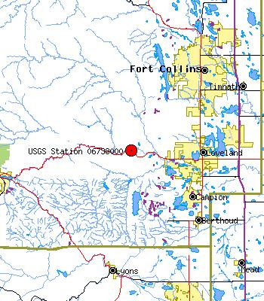
Figure 1. Drake Measuring Station (USGS, 2006a)
The Loveland measuring station is described as USGS06741510 Big Thompson River at Loveland, CO (USGS, 2006b). Its location is Latitude 40°22'43", Longitude 105°03'38" NAD27, Larimer County, Colorado, Hydrologic Unit 10190006.
Its drainage area is 535 square miles and is located 4,906.00 feet above sea level NGVD29. The data for the Loveland measuring station is as follows:
Data Type Begin Date End Date Count
Peak stream flow 1979-08-19 2005-06-26 27
Daily Data 1979-07-04 2006-11-13 9995
Daily Statistics 1979-07-04 2005-09-30 9586
Monthly Statistics 1979-07 2005-09
Annual Statistics 1979 2005
Field/Lab water-quality samples
1979-06-28 2005-09-22 428
The records for this site are maintained by the USGS Colorado Water Science Center p (USGS, 2006a). The following map depicts the location of the Loveland measuring station.
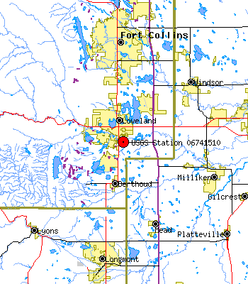

Figure 2. Loveland Measuring Station (USGS, 2006a)

For each data set, five stations are considered to collect data. For each station, nine independent variables are used: Tmax, Tmin, Tobs, Tmean, Cdd, Hdd, Prcp, Snow and Snwd.
Tmax is the maximum measured temperature at the gauging site during the 24-hour measuring period.
Tmin is the lowest measured temperature at the gauging site during the 24-hour measuring period. Tobs is the current temperature at the gauging site at the time of the report.
Tmean is the average temperature during the 24-hour measuring period at the gauging site.
Cdd are the Cooling Degree Days, an index of relative coldness.
Hdd are the Heating Degree Days, an index of relative warmth.
Prcp is the measured rainfall during the 24-hour measuring period.
Snow1 is the measured snowfall during the 24-hour measuring period.
Snwd is the measured depth of the snow at the measuring site at the time of the report.
The output variable is the predicted flood level. Data was collected during a 7 year, 10 month, and 3 day period. This is the actual data collected by the meteorological stations. The samples for each site are more than 3000 data sets which are more than enough to (a) run a NN model, (b) to test it, and (c) to validate it. For the same data, a linear regression model using SPSS was run. The same variables dependent and independent were considered. After cleaning the data, a step that is required for linear regression models, more than 1800 data sets were considered. The model used a stepwise regression in which the model will consider one independent variable at a time until all the independent variables are considered (Mazouz, 2006).
To develop and test such a model, a specific watershed was selected. Many watersheds in the U.S. are relatively limited in surface area and have well documented histories of rainfall and subsequent flooding ranging from minor stream bank inundation to major flooding events. Such a watershed was selected so that historical data could be used to train the NN system and to test it.

Neural Networks
NNs are based on biological models of the brain and the way it recognizes patterns and learns from experience. The human brain contains millions of neurons and trillions of interconnections working together allowing it to identify one person in a crowd or to pick up one voice at a cocktail party. The structure allows the brain to learn quickly from experience. A NN is comprised of interconnected processing units that work in parallel, much the same as the networks of the brain, and can discern patterns from input that is ill-identified, chaotic, and noisy.
Advantages of using NNs include the following:
1. A priori knowledge of the underlying process is not required.
2. Existing complex relationships among the various aspects of the process under investigation need not be recognized.
3. Solution conditions, such as those required by standard optimization or statistical models, are not preset.
4. Constraints and a priori solution structures are neither assumed nor enforced (French et al., 1992).
A NN is composed of three layers of function. They consist of (a) an input layer, (b) a hidden layer, and (c) an output layer. The hidden layer may consist of several hidden layers as is depicted in Figure 3.
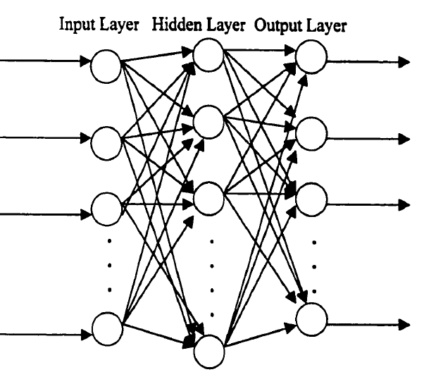

Figure 3. Diagram (Mashudi, 2001)

The input layer receives or consists of the input data. It does nothing but buffer the input data. The hidden layers are the internal functions of the NN. The output layer is the generated results of the hidden layers.
The two types of s are (a) feed-forward network and (b) a feedback network. The feed-forward NN has no provision for the use of output from a processing element (hidden layer) to be used as an input for a processing unit in the same or preceding hidden layer. A feedback network allows outputs to be directed back as input to the same or preceding hidden layer. When these inputs create a weight adjustment in the preceding layers, it is called back propagation. An NN learns by changing the weighting of inputs. During training, the NN sees the real results and compares them to the NN outputs. If the difference is great enough, the NN then uses the feedback to adjust the weights of the inputs. The feedback learning function defines an NN.
The general procedure for network development is to choose a subset of the data containing the majority of the flooding events, train the network, and test the network against the remaining flooding events. In this situation, the recorded documented flooding events over the recorded history of the watershed would be divided into two sets—one large training set and a second smaller testing set. Once the NN has been trained and tested for accuracy, it can be updated on a continuing basis using data provided via tele-connections from rain gauges, depth gauges, flow rates meters, and depth gauges throughout the watershed. At the same time, the NN would be able to provide accurate flooding impact maps for every precipitation event as the event is occurring. If an ES is tied to this computer, it would be able to use this data to determine affected areas and populations. The ES can, at the same time, produce maps of evacuation corridors, emergency response corridors, and transportation corridors that are unaffected and still usable during the flood event. This will (a) speed the evacuation of areas that are in danger of flooding, (b) allow the most rapid emergency response, and (c) provide usable routes for transportation of emergency and recovery supplies into the disaster area.

Definitions
As has happened in many fields, NNs have generated their own terms and expressions that are used differently in other fields. To prevent confusion, the following are the definitions of specific terms used in NNs (Markus, 1997):
Activation is the process of transforming inputs into outputs.
Architecture is the arrangement of nodes and their interconnections, (structure).
Activation Function is the basic function that transforms inputs into outputs.
Bias and Weights are the model parameters (Biases are also known as shifters. Weights are called rotators).
Epoch is the iteration or generation.
Layers are the elements of the NN structure (input, hidden, and output).
Learning is the training and parameter estimation process.
Learning Rate is a constant (or variable) which shows how much change in error affects change in parameters. This should be defined prior to program run.
Momentum is a term that includes inertia into iterative parameter estimation process. Parameters depend not only on the error surface change, but also on the previous parameter correction (assumed to be constant and equal to one).
Nodes are parts of each layer. The input nodes represent single or multiple inputs. Hidden nodes represent activation functions. Output nodes represent single or multiple outputs. The number of input nodes is equal to the number of inputs. The number of hidden nodes is equal to the number of activation functions used in computation. The number of output nodes equals the number of outputs.
Normalization is a transformation that reduces a span between the maximum and minimum of the input data so that it falls within a sigmoid range (usually between -1 and +1).
Overfitting is when there are more model parameters than necessary. A model is fitted on random fluctuations.
Training is the learning and parameter estimation process.

Ward System Neuralshell Predictor
The Ward Systems product, selected for the research, is the NeuralShell Predictor, Rel. 2.0, Copyright 2000. The following description was taken directly from the Ward Systems website, www.wardsystems.com (Ward Systems Group, 2000). All NNs are systems of interconnected computational nodes (Mazouz, 2003). There are three categories of nodes: (a) Input nodes, (b) Hidden nodes, and (c) Output nodes. This is depicted in the Figure 3.
Input nodes receive input from external sources. The hidden nodes send and receive data from both the input nodes and the output nodes. Output nodes produce the data that is generated by the network and sends the data out of the system (Ward Systems Group, 2000).
NNs are defined as massively parallel interconnected networks of simple elements and their hierarchical organizations which are intended to interact with the objects of the real world in the same way as biological nervous systems (Kohonen, 1988).
A simplified technical description of General Regression NN (GRNN) used by the Ward Systems Group follows:
The General Regression NN (GRNN) used by Ward Systems is an implementation of Don Specht's Adaptive GR. Adaptive GRNN has no weights in the sense of a traditional back propagation NN. Instead, GRNN estimates values for continuous dependent variables using non-parametric estimators of probability density functions. It does this using a ‘one hold out’ during training for validation. In these estimations, separate smoothing factors (called sigmas by Specht) are applied to each dimension to improve accuracy (MSE between actual and predicted). Large values of the smoothing factor imply that the corresponding input has little influence on the output, and vice versa. Thus by finding appropriate smoothing factors, the dimensionality of the feature space is reduced at the same time accuracy is improved. The smoothing factor for a given dimension may become so large that the dimension is made irrelevant, and hence the input is effectively eliminated.

Specht has used conjugant gradient techniques to find optimum values for smoothing factors, i.e., the set that minimizes MSE. Ward Systems Group accomplishes the same thing with a genetic algorithm. Ward Systems Group's implementation then transforms the smoothing factors into contribution factors for each input. Since smoothing factors are the only adjustable variables (weights) in adaptive GRNN, the optimal selection of them provides a very accurate feature selection at the same time the network is trained.

Since adaptive GRNN is trained using the ‘one hold out’ method, it is much less likely to overfit than traditional neural nets and other regression techniques that simply fit non-linear surfaces tightly through the data. Therefore, training results for adaptive GRNN may be worse than training results for other non-linear techniques. However, to some degree, the training set can also be out-of sample set as well if exemplars are limited. Of course, for irrefutable out-of-sample results, a separate validation set is appropriate(Ward Systems Group, 2000).

Methods of Statistical Validation

The methods of statistical validation to be used in this paper are as follows:
R-Squared is the first performance statistic known as the coefficient of multiple determination, a statistical indicator usually applied to multiple regression analysis. It compares the accuracy of the model to the accuracy of a trivial benchmark model wherein the prediction is just the average of all of the example output values. A perfect fit would result in an R-Squared value of 1, a very good fit near 1, and a poor fit near 0. If the neural model predictions are worse than one could predict by just using the average of the output values in the training data, the R-Squared value will be 0. Network performance may also be measured in negative numbers, indicating that the network is unable to make good predictions for the data used to train the network. There are some exceptions, however, and one should not use R-Squared as an absolute test of how good the network is performing. See below for details.
The formula the NeuroShell® Predictor uses for R-Squared is the following (y is the output value: cubic feet per minute of outflow).
$R^{2}=1−{\text{SSE}}/{{\text{SS}}_{\text{YY}}}$

$\text{SSE}=\sum{(y−\hat{y})^{2}},{\text{SS}}_{\text{YY}}=\sum{(y−\bar{y})}{\begin{aligned}2\end{aligned}}^{}$

Where

$y$is the actual value.

$\hat{y}$is the predicted value of y, and

$\bar{y}$is the mean of the y values.

This is not to be confused with r-squared, the coefficient of determination. These values are the same when using regression analysis, but not when using NNs or other modeling techniques. The coefficient of determination is usually the one that is found in spreadsheets. One must note that sometimes the coefficient of multiple determination is called the multiple coefficient of determination. In any case, it refers to a multiple regression fit as opposed to a simple regression fit. In addition, this should not be confused with r, the correlation coefficient (Ward Systems Group, 2000).
R-Squared is not the ultimate measure of whether or not a net is producing good results. One might decide the net is okay by (a) the number of answers within a certain percentage of the actual answer, (b) the mean squared error between the actual answers and the predicted answers, or (c) one’s analysis of the actual versus predicted graph, etc. (Ward Systems Group, 2000).
There are times when R-Squared is misleading, e.g., if the range of the output value is very large, then the R-Squared may be close to one yet the results may not be close enough for your purpose. Conversely, if the range of the output is very small, the mean will be a fairly good predictor. In that case, R-Squared may be somewhat low in spite of the fact that the predictions are fairly good. Also, note that when predicting with new data, R-Squared is computed using the mean of the new data, not the mean of the training data (Ward Systems Group, 2000).
Average Error is the absolute value of the actual values minus the predicted values divided by the number of patterns.
Correlation is a measure of how the actual and predicted correlate to each other in terms of direction (i.e., when the actual value increases, does the predicted value increase and vice versa).

$r=N⋅\left[\sum_{i=1}^{N}{(x_{i}⋅y_{i})}\right]−{\left[\sum_{i=1}^{N}{x_{i}}\right]⋅\left[\sum_{i=1}^{N}{y_{i}}\right]}/{\sqrt{N⋅\left[\sum_{i=1}^{N}{x_{i^{2}}}\right]−{\left[\sum_{i−1}^{N}{x_{i}}\right]}^{2}}}⋅\sqrt{N⋅\left[\sum_{i=1}^{N}{y_{i^{2}}}\right]−{\left[\sum_{i=1}^{N}{y_{i}}\right]}^{2}}$

This is not a measure of magnitude. The values for r range from zero to one. The closer the correlation value is to one, the more correlated the actual and predicted values (Ward Systems Group, 2000).
Mean Squared Error is a statistical measure of the differences between the values of the outputs in the training set and the output values the network is predicting. This is the mean over all patterns in the file of the square of the actual value minus the predicted value, (i.e., the mean of actual minus the predicted) The errors are squared to penalize the larger errors and to cancel the effect of the positive and negative values of the differences (Ward Systems Group, 2000).
Root Mean Squared Error (RMSE) is the square root of the MSE.
Percent in Range is the percent of network answers that are within the user-specified percentage of the actual answers used to train the network (Ward Systems Group, 2000).

Chapter 4: Analysis and Presentation of Findings
In this chapter, the Ward Systems Neural Shell Predictor is applied to model rainfall/snowmelt-runoff relationship using observed data from the Big Thompson watershed located in North-central Colorado. It was originally assumed that the rainfall would be the predominant factor in this watershed. However, subsequent research strongly indicated that snowmelt generally was the most critical input. Numerous runs of data were done to demonstrate the impact of various training data inputs. Several of those runs are presented in this chapter to demonstrate the evolution of the final model. For each run, an evaluation of the network reliability is presented. A procedure is then presented for the systematic selection of input variables.
The Ward Systems Neural Shell Predictor is an extremely versatile program offering a number of choices of data processing and error criteria. These choices are also discussed.

Evaluation of Model Reliability
In this research, the performance of the model is measured by the difference between the observed and predicted values of the dependent variable (runoff) or the errors.
The network performance statistic known as R-Squared, or the coefficient of multiple determination, is a statistical indicator usually applied to multiple regression analysis. It compares the accuracy of the model to the accuracy of a trivial benchmark model wherein the prediction is just the average of all of the example output values. A perfect fit would result in an R-Squared value of one, a very good fit near one, and a poor fit near zero. If the neural model predictions are worse than could be predicted by just using the average of the output values in the training data, the R-Squared value will be zero. Network performance may also be measured in negative numbers indicating that the network is unable to make good predictions for the data used to train the network. There are some exceptions, however, and one should not use R-Squared as an absolute test of how good the network is performing.
Average Error is the absolute value of the actual values minus the predicted values divided by the number of patterns.
Correlation (as defined in Chapter 3) is a measure of how the actual and predicted correlate to each other in terms of direction (i.e., when the actual value increases, does the predicted value increase and vice versa). This is not a measure of magnitude. The values for r range from zero to one. The closer the correlation value is to one, the more correlated the actual and predicted values (Ward Systems Group, 2000).
Mean Squared Error is the statistical measure of the differences between the values of the outputs in the training set and the output values the network is predicting. This is the mean over all patterns in the file of the square of the actual value minus the predicted value. That is the mean of (actual minus predicted) squared. The errors are squared to penalize the larger errors and to cancel the effect of the positive and negative values of the differences (Ward Systems Group, 2000). RMSE is the square root of the MSE.
Percent-in-Range is the percent of network answers that are within the user-specified percentage of the actual answers used to train the network (Ward Systems Group, 2000).

The Big Thompson Watershed
The Big Thompson watershed is located in North-central Colorado. Below the Estes Park Lake, impounded by Olympus Dam, all the way to the City of Loveland, Colorado, the Big Thompson River runs through a narrow and steep canyon. On July 31, 1976, the Big Thompson Canyon was the site of a devastating flash flood. The flood killed 145 people, six of whom were never found. This flood was caused by multiple thunderstorms that were stationary over the upper section of the canyon. This storm event produced 12 inches of rain in less than four hours. At 9:00 in the evening, a 20-foot wall of water raced down the canyon at about six meters per second, about 14 miles per hour. The flood destroyed 400 cars, 418 houses, and 52 businesses. It also washed out most of U.S. Route 34, the main access and egress road for the canyon. The flood was more than four times as strong as any flood in the 112-year record of the canyon. Flooding of this magnitude has happened every few thousand years based on radiocarbon dating of sediments (Hyndman & Hyndman, 2006).
The following map depicts the watershed. It is a section of a map from the Northern Colorado Water Conservation District.
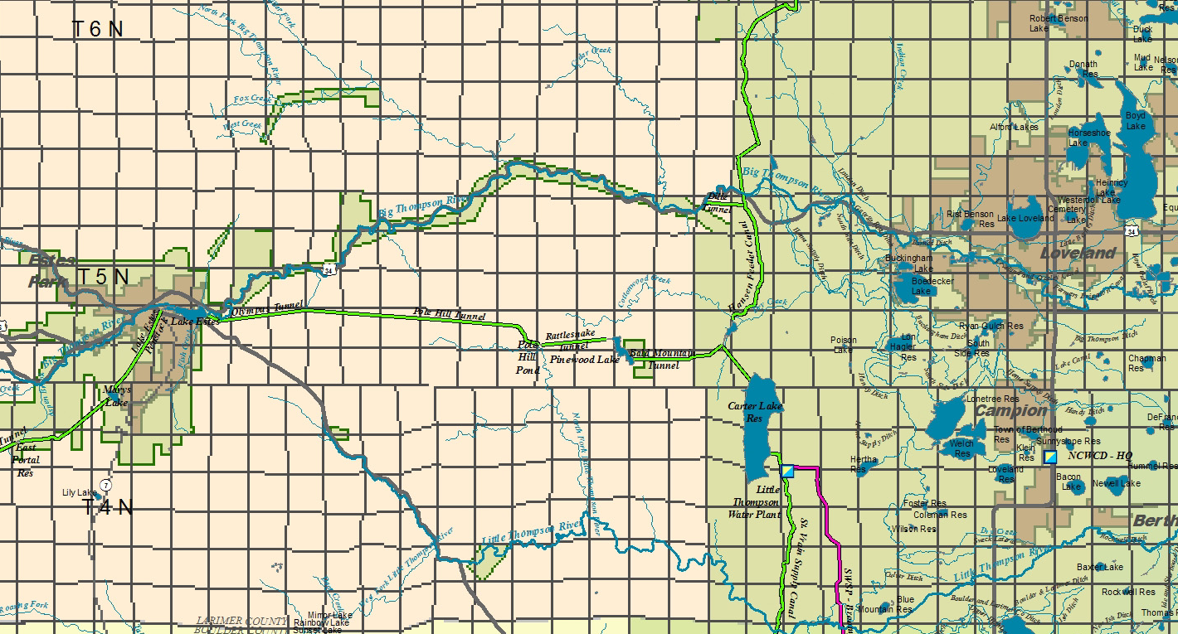

Figure 4. Big Thompson Watershed (NCWCD, 2005)
The following is a topographic map of the Big Thompson canyon. It is a narrow, relatively steep canyon.

Figure 5. Topography of the Big Thompson Canyon (USGS & Inc, 2006).

Modeling Procedure
The historical measurements of (a) precipitation, (b) snowmelt, (c) temperature, and (d) stream discharge are available for the Big Thompson Watershed as they are usually available for most watersheds throughout the world. This is in contrast to data on (a) soil characteristics, (b) initial soil moisture, (c) land use, (d) infiltration, and (e) groundwater characteristics that are usually scarce and limited. A model that could be developed using the readily available data sources would be easy to apply in practice. Because of this, the variables of (a) precipitation, (b) snowmelt, and (c) temperature are the inputs selected for use in this model and stream discharge is the output.
The selection of training data to represent the characteristics of a watershed and the meteorological patterns is critical in modeling. The training data should be large enough to fairly represent the norms and the extreme characteristics and to accommodate the requirements of the NN architecture.
For this study of the Big Thompson Watershed, six climatic observation stations were used for the input variables. For the purposes of building a model to demonstrate the feasibility of using the commercially available NN, all six stations’ data were used for the independent variables. The description and locations of the stations are on the following page.

Coopid. Station Name Ctry. State County Climate Div. Latitude Longitude Elevation

------ -------------- ------ ----- -------------- ------- --------- ---------

051060 Buckhorn Mtn 1E U.S. CO Larimer 04 40:37 -105:18 2255.5

052759 Estes Park U.S. CO Larimer 04 40:23 -105:29 2279.9

052761 Estes Park 1 SSE U.S. CO Larimer 04 40:22 -105:31 2372.9

054135 Hourglass Reservoir U.S. CO Larimer 04 40:35 -105:38 2901.7

055236 Loveland 2N U.S. CO Larimer 04 40:24 -105:07 1536.2

058839 Waterdale U.S. CO Larimer 04 40:26 -105:13 1594.1

(NCDC, 2006)

The period of time for the historical data selected was from July 4, 1990, through May 7, 1998, a total of seven years, ten months and three days. The period was selected because of the discontinuation of stations and addition of new stations over the history of the Big Thompson. The period offered the longest time frame with no station changes, and it provided an adequate number of observations for the NN as well as a reasonable number of extreme observations. This allowed the NN to adequately predict extreme runoff conditions. If the project was attempting to predict current and future stream runoff conditions, one would likely use the most current data available. The data would, by necessity, be rerun on a periodic basis for the most accurate predictions.
The data is comprised of (a) daily precipitation, (b) snowmelt, (c) temperature, and (d) stream discharge. The data for training and testing this model was obtained from the National Climatic Data Center’s website (NCDC, 2006). The data is free and available to academic and research organizations.

Procedure Followed in the Model
In this dissertation, the reference to a “run” means that a major change in data was implemented. Each “run” consisted of dozens of program processes and should not be interpreted as a single program process.
Previous studies indicated that for the NN to work efficiently, the data required cleaning. This means that any gaps in data reporting were eliminated as well as erroneous reports generated when the stations were periodically calibrated or malfunctioning. To this end, the data used in this model was taken directly from the files of the National Climatic Data Center and cleaned of all gaps, missing data, and non-reporting days.
While Ward Systems Group states that the program internally checks for accuracy and that out-of-sample data is not required to validate predictive capability, it seemed that the results would be more credible using test data that were not part of the training data. All runs reported in this paper use 365 days of data that were not part of the training data. These 365 days are the last 365 lines of input data in each run.
The following table outlines the steps taken in creating the model.
Table 1
Steps in the use of Neural Networks
STEP—PROBLEM INPUT | Activities | Definitions and comments
1.1 Organizing the Data  1.2 Buffering the Data | Problem Input.  - Cleansing the data | Elimination of ‘No report’ days.
BUILD THE NEURAL NETWORK | TRAIING
2.1 Select Strategy  2.1 Selecting training set  2.2 Selecting the run set  2.3 Train the Network | Select Generic or Neural Model for prediction problem. (p48) | Establish the nodes, paths and weights for nodes and paths.  Use multiple runs to smooth the input error terms and optimize the desired characteristic (Correlation or MSE,)  Smoothing factors (weights) are the only adjustable variables in the Genetic model. (Ward, p 48)
APPLY THE NEURAL NETWORK | ACTIVIATION
3. 1 Run the model using hold-out set of data |  | Back propagate to adjust the weights and eliminate smoothed inputs.
3.2 Run another iteration using hold-out set |  | Testing the model.
POST NETWORK and | PROBLEM OUTPUT
4.2 Problem Output | File export, data examination, printouts. | Organize and evaluate efficiency of the model

Neuroshell Predictor in (Ward Systems Group, 2000)
Late in this study, a paper by (Hsu et al., 1996), demonstrated that results were dramatically improved by adding the previous day’s stream flow or stage level input with the other data. This technique was applied in the final run of this study. This application resulted in a dramatic improvement of the predictive capability of the model (Hsu et al., 1996).
Percent-in-Range is the percent of network answers that are within the user-specified percentage of the actual answers used to train the network (Ward Systems Group, 2000). Initially, the percent-in-range criterion was set at 20 cubic feet per minute (cfm). This resulted in a very poor percent in range result. While a variation of 20 cfm is significant at low water levels, it is miniscule at the critical extreme events such as flooding. In all the runs, including the final and most successful run, the percent in range criteria was set at 100 cfm. A variation of 100 cfm at flood stage results in less than a few inches of water level, the critical test for this model.

Initial Run Results
The initial run of the data that did not include the previous day’s stream flow and the Lake Estes discharge. It resulted in promising but not particularly good results. The following charts demonstrate the initial runs.
These charts depict the actual values versus the predicted cfm flow values using data from the five climatic gauging stations. The measuring stations are Drake and Loveland. As one can see, there is a definite correlation between the input data and the resulting values. However, the extreme values are very poorly predicted.
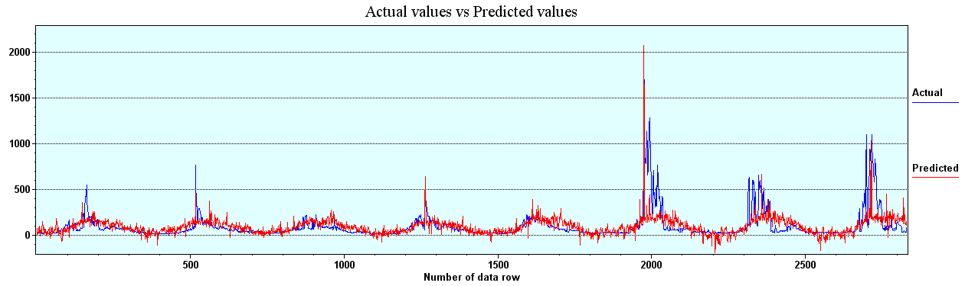Figure 6. Drake, Initial Run Actual vs. Predicted Values

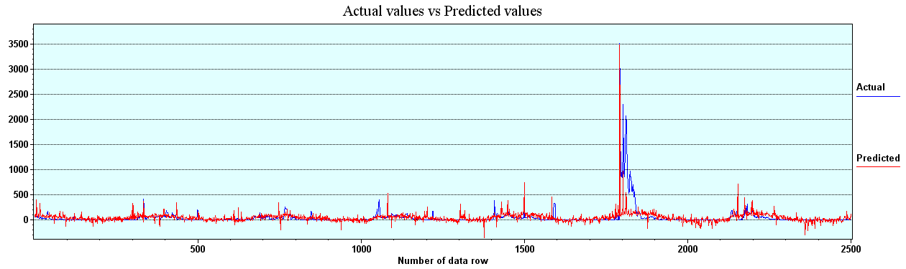

Figure 7. Loveland, Initial run Actual vs. Predicted Values
The R-Squared results are depicted in the graph below. The R-Squared started at a value of approximately .24 and improved over the addition of 80 hidden neurons to an approximate .36 value. While promising, the results were not good enough to use as a predictive program.
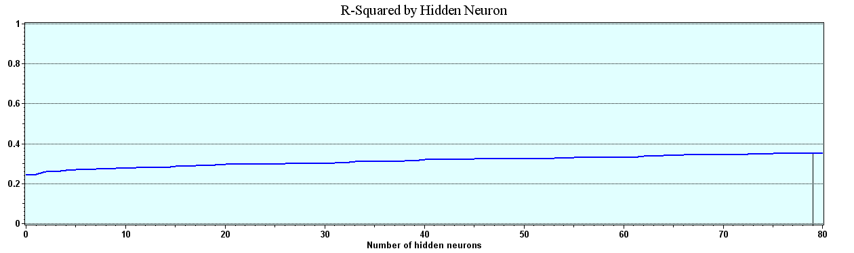

Figure 8. Drake, Initial Run R-Squared

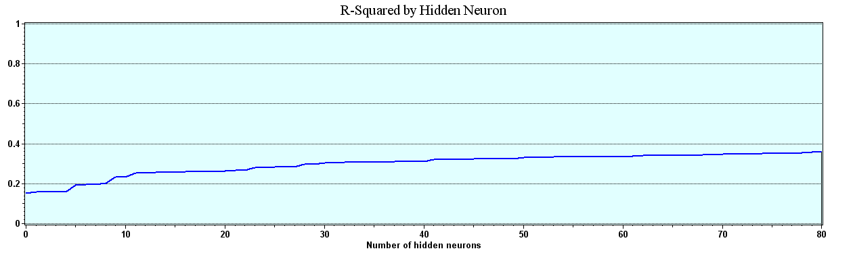

Figure 9. Loveland, Initial Run R-Squared
The Average Error of the program, after a short initial increase, declined steadily through the generation of 80 hidden neurons. The result is to be expected from a NN. Still, the results are not adequate for use as a flood prediction tool.
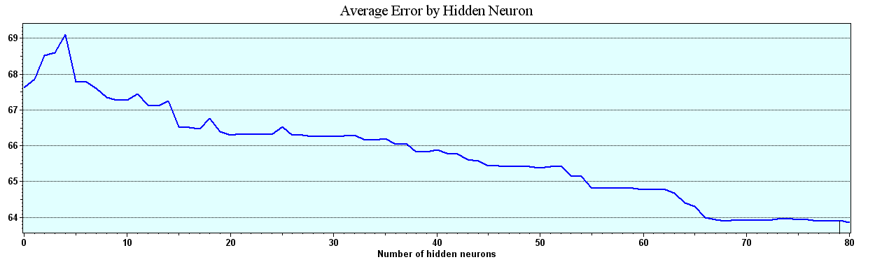

Figure 10. Drake, Initial Run Average Error

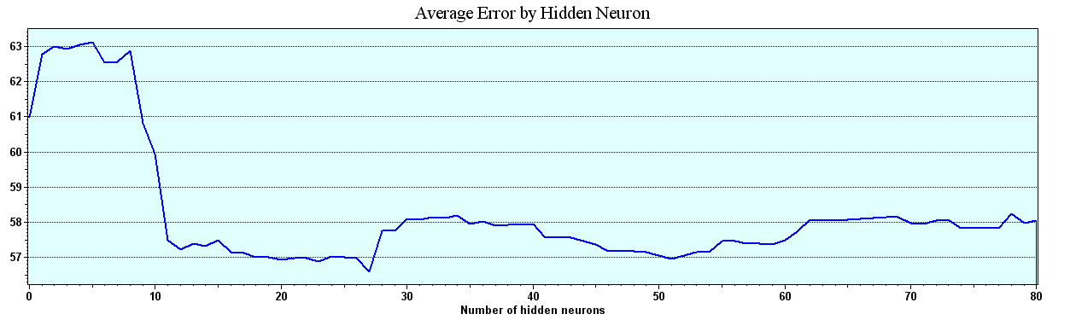

Figure 11. Loveland, Initial Run Average Error
The Correlation results of this run of data start at about .5 and gradually increase to a maximum of .5933. The Loveland measuring station results started below .5 and increased to a maximum of .60235.
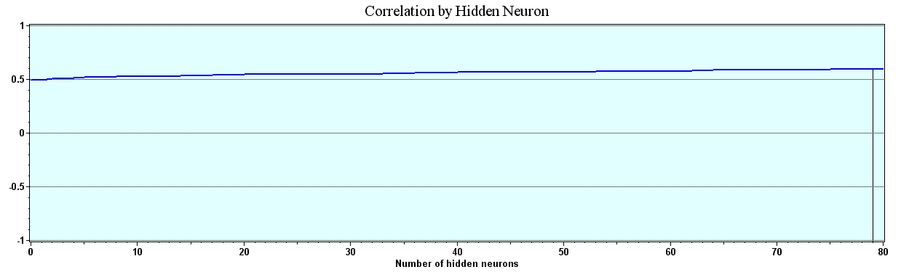

Figure 12. Drake, Initial Run Correlation

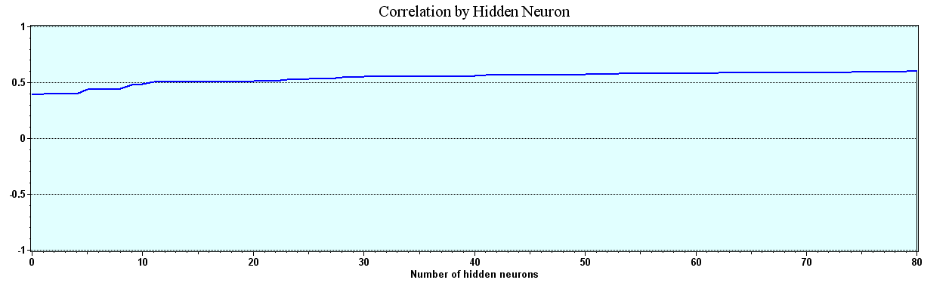

Figure 13. Loveland, Initial Run Correlation
The Percent-in-Range results are based on a range of plus or minus 100 cubic feet per minute. This result is particularly interesting from a predictive standpoint. These results are again promising but not sufficient for flood prediction. The best Percent-in-Range figures came from the Loveland measuring station with maximum of 90.5 percent in range.
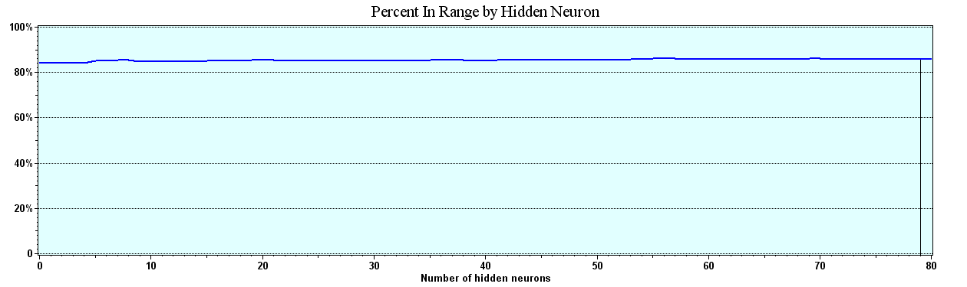

Figure 14. Drake, Initial Run Percent in Range

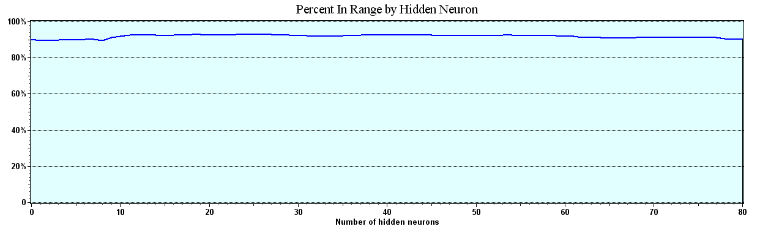

Figure 15. Loveland, Initial Run Percent in Range

Second Run Results
The second run was initiated by adding outflow data from the main power plant dam located at Lake Estes on the upper Big Thompson River. This is the controlling dam on the Big Thompson River, which is situated above the two measuring stations that this study uses for the model. All inputs are identical to the first run.
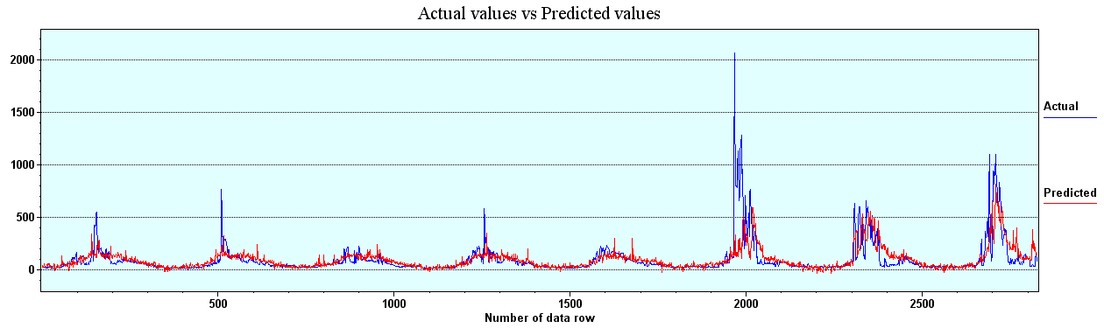

Figure 16. Drake, Second Run, Actual verses Predicted
The actual value verses predicted values for the Drake measuring station and the Loveland measuring station both show definite improvement over the previous run. This run, with the outflow from Lake Estes, still is rather poor on predicting the extreme values associated with flooding events and as such are not adequate. 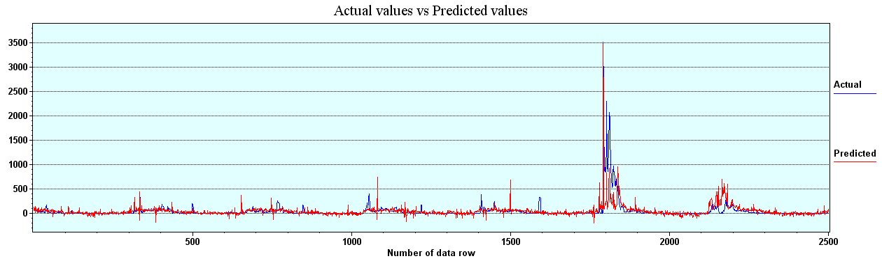
Figure 17. Loveland, Second Run, Actual verses Predicted

The R-Squared value for this run at the Drake measuring station started just above .4 and did not improve through the addition of 80 hidden neurons. The R-Squared values for the Loveland measuring station started just above .24 and improved over the addition of 80 neurons to a value of .4600. Both stations showed significant improvement for the R-Squared values over the values from the first run.
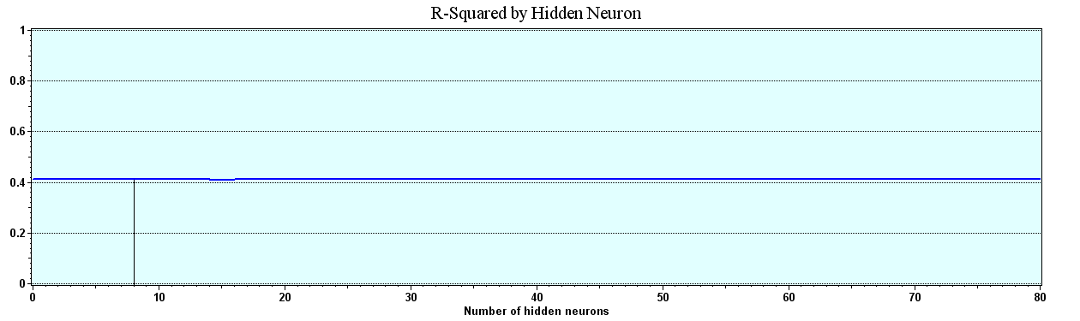

Figure 18. Drake, Second Run, R-Squared
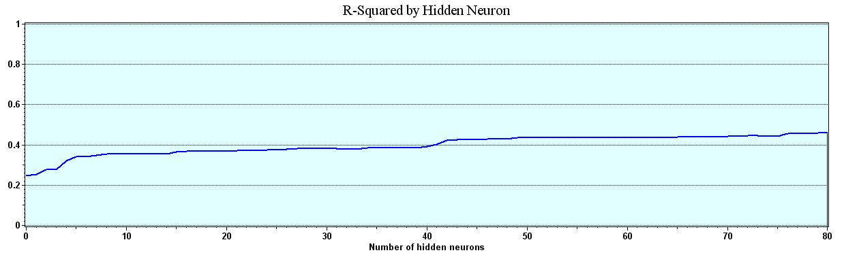

Figure 19. Loveland, Second Run, R-Squared
The average error for both Drake and Loveland measuring stations on this run showed a dramatic improvement over the previous run. This would be expected since this run included better constant flow information provided by the outflow from Lake Estes.
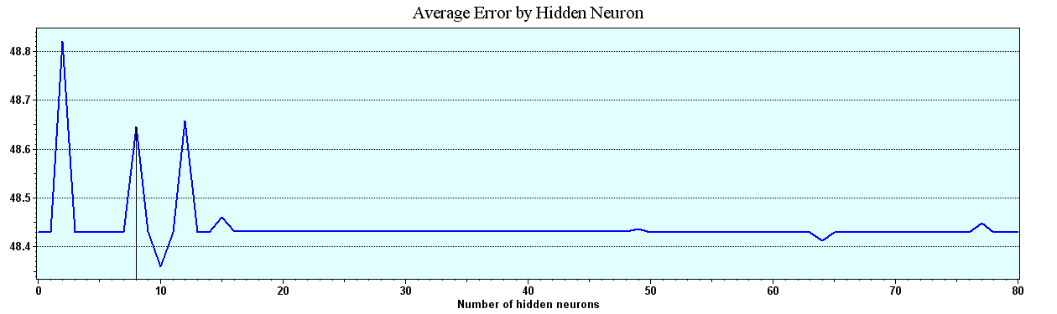

Figure 20. Drake, Second Run, Average Error
The Average Error at the Loveland measuring station reached a low of about 42.2 cubic feet per minute at the addition of the 78th hidden neuron and finished at 49.94 cubic feet per minute. Again, this was a major improvement over the first run.
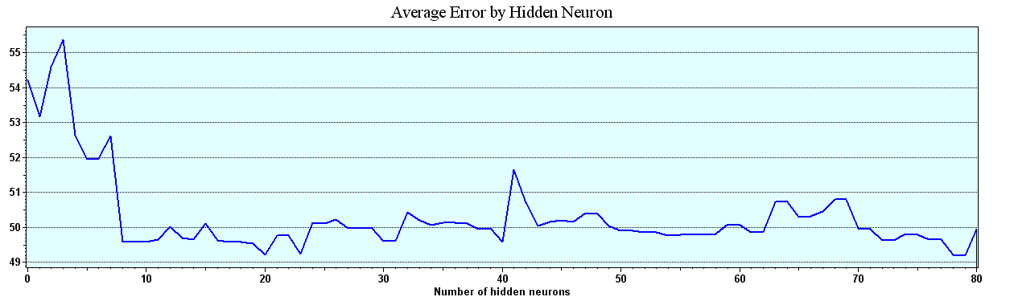

Figure 21. Loveland, Second Run, Average Error
The Correlation by Hidden Neuron for this data run at the Drake measuring station started at about .6418 and never measurably improved over the course of adding 80 hidden neurons. The Loveland measuring station’s Correlation started at about .5 and improved over the course of adding 80 hidden neurons to a value of .6783. Both results are better than the results of the first run. However, these results are still not adequate for a successful predictive program.
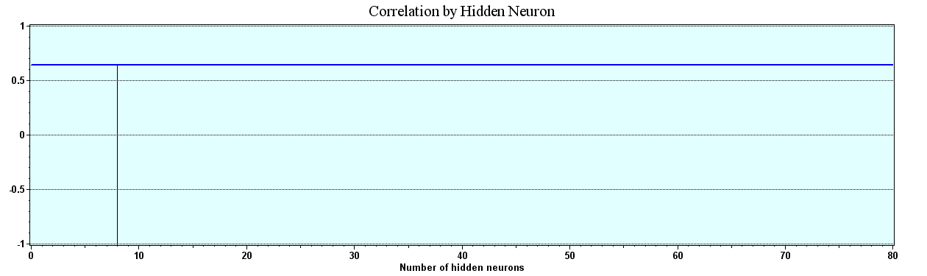

Figure 22. Drake, Second Run Correlation
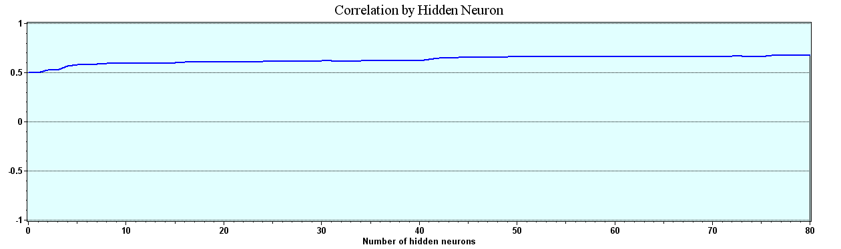

Figure 23. Loveland, Second Run, Correlation
The Drake Percent-in-Range for this run showed no improvement over the first run with the Drake measuring station starting and ending at 90.0 percent-in-range. The Loveland Percent-in-Range started at about 90 percent and did improve to 92 percent. While better than the first run, the results are not adequate for flood prediction.
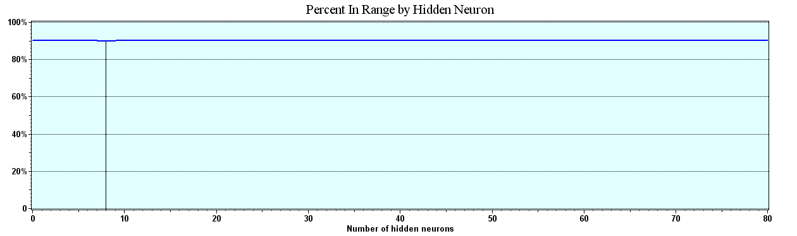

Figure 24. Drake, Second Run, Percent in Range
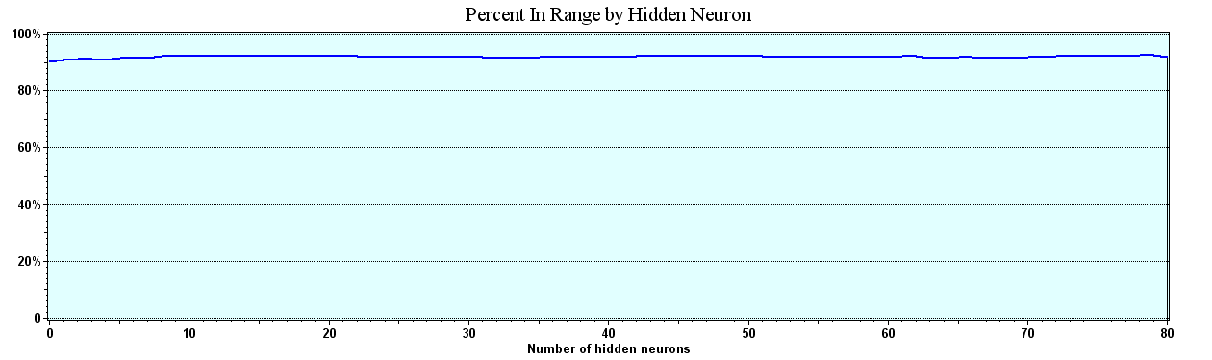

Figure 25. Loveland, Second Run, Percent in Range

Final Model Results
The final run was initiated after a major breakthrough occurred in this research, which was the finding and implementing a technique used by (Hsu et al., 1996). This technique demonstrated that results were significantly improved by adding the previous day’s stream-flow or stage-level input with the other data.
The same inputs are used in this run of data as were used in the two previous models. The new input for this data run is the previous day’s flow at the Drake and Loveland measuring stations, respectfully.
The Actual versus Predicted results for both the Drake and the Loveland measuring stations are greatly improved in this final model as demonstrated by the charts below and the following statistical analysis. One extreme event occurred during this time period that was well out of the range of data available and was not adequately predicted by this NN. It is well known that a NN cannot predict an event that it has never seen before in the training data. There was no repeat of the magnitude of this event during the time period under study.

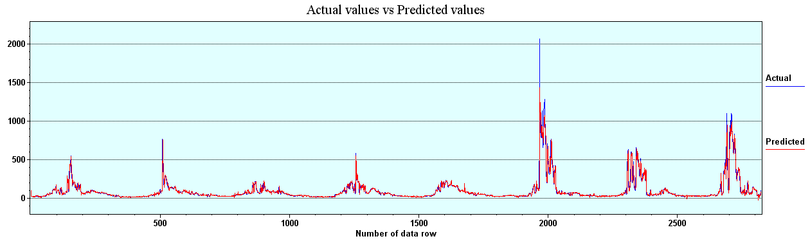
Figure 26. Drake Final Model, Actual versus Predicted.
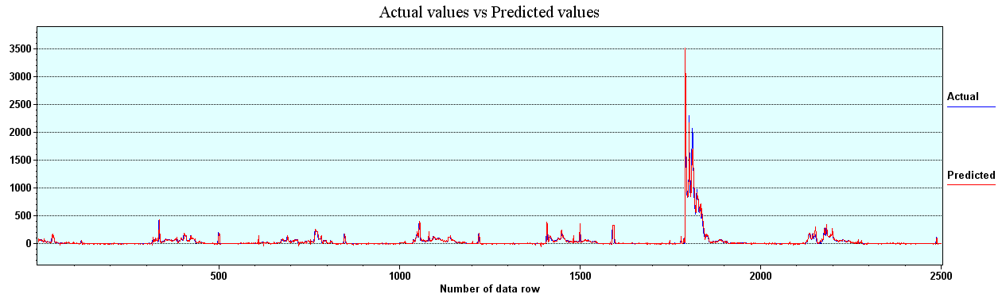
Figure 27. Loveland, Final Model, Actual versus Predicted.
R-Squared for this run improved greatly over the first two models for both measuring stations.
The Drake measuring station results for R-Squared started at just under .90 and improved slightly over the addition of 80 hidden neurons to a value of .9091.
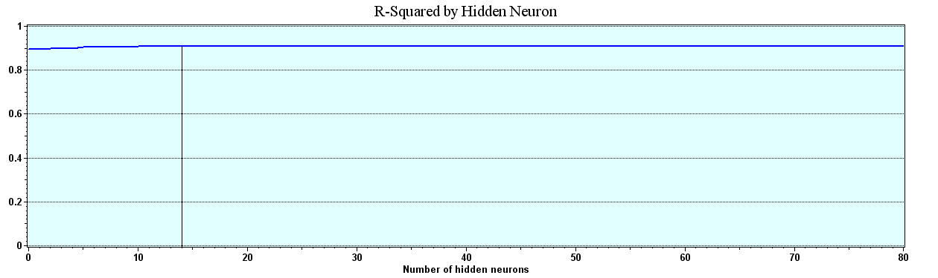
Figure 28. Drake, Final Model, R-Squared.
The R-Squared results for Loveland started at about .86 and improved over the run of data to a value of .9671.
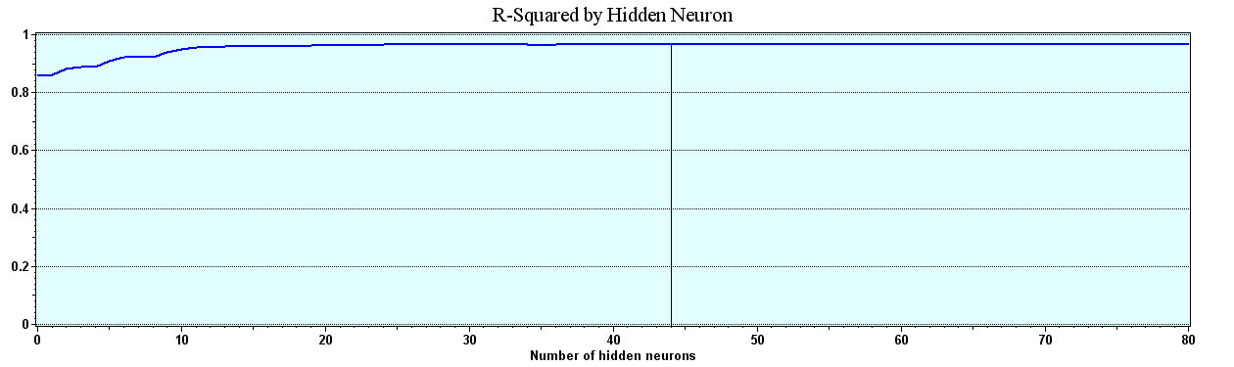
Figure 29. Loveland, Final Model, R-Squared.
The Average Error for the final model improved dramatically over the results of the first two models. Both the Drake measuring station and the Loveland measuring station showed very tight average errors.
The Average Error for the Drake Measuring station started the run at about 15.7 cubic feet per minute and decreased over the run to a final value of 15.24 cubic feet per minute.
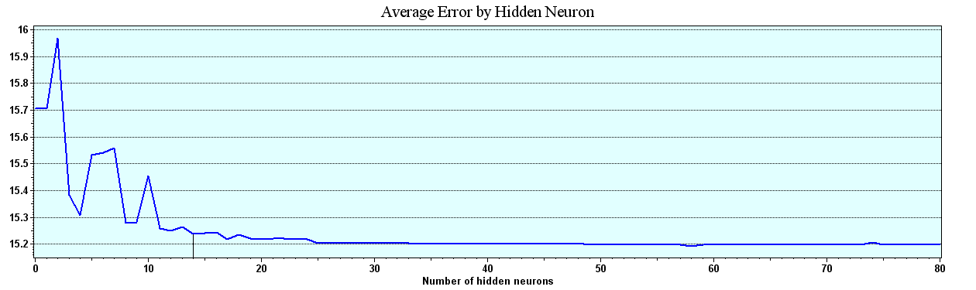
Figure 30. Drake, Final Model, Average Error.
The Average Error for the Loveland measuring station started the run at about 26 cubic feet per minute and decreased to a value of 11.56 Cubic feet per minute.
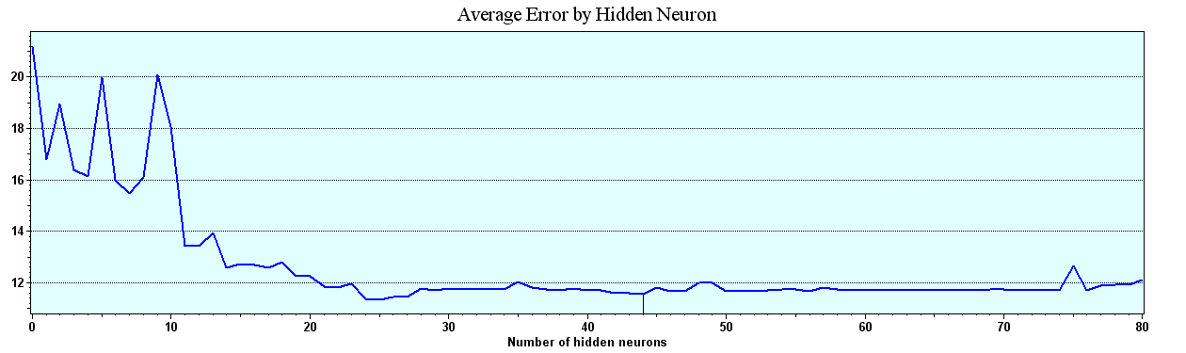
Figure 31. Loveland, Final Model, Average Error.
The Correlation values for both the Drake measuring station and the Loveland measuring station for this model are very good.
The Correlation for this model at the Drake measuring station is .9534.
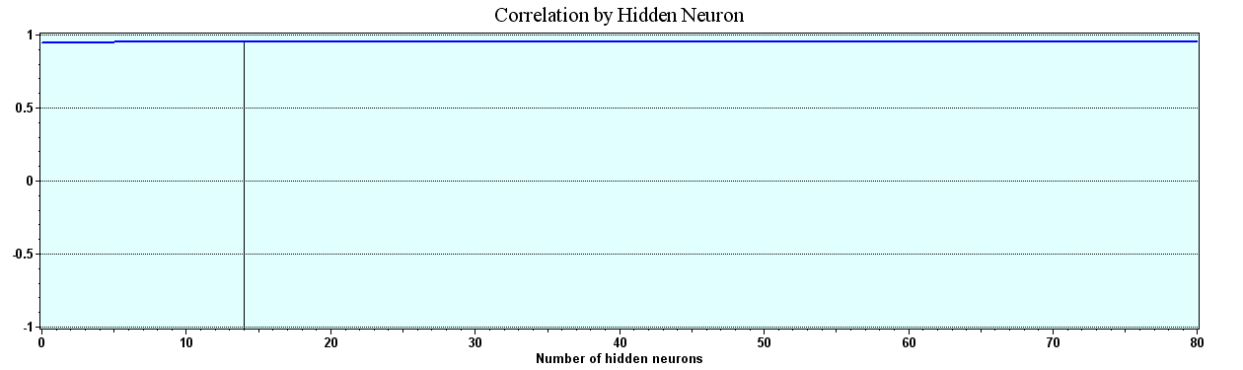
Figure 32. Drake, Final Model, Correlation.
The Correlation at the Loveland measuring station is 98.34.
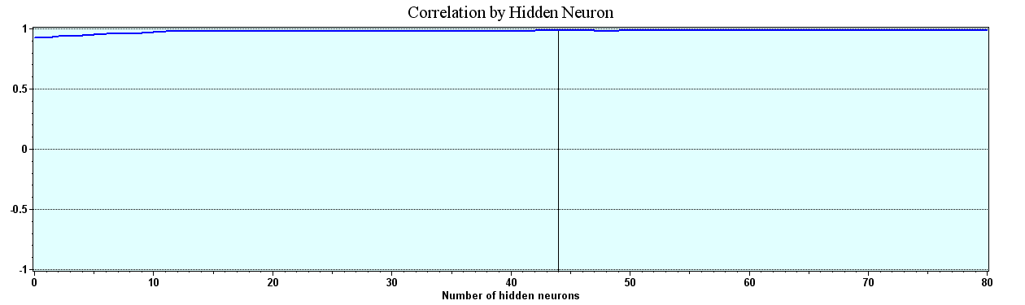
Figure 33. Loveland, Final Model, Correlation.
For this final model, both Mean Squared Error and RMSE are calculated and presented below.
The Mean Squared Error as measured for the Drake measuring station started at a value of 2280 and declined over the addition of 80 hidden neurons to a value of 1993.011.
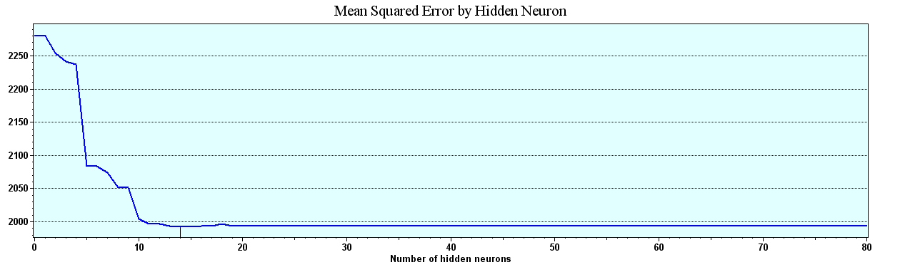
Figure 34 Drake. Final Model Mean Squared Error.
The Mean Squared Error for the Loveland measuring station started at a value of about 4400 and declined to a value of 1016.943.
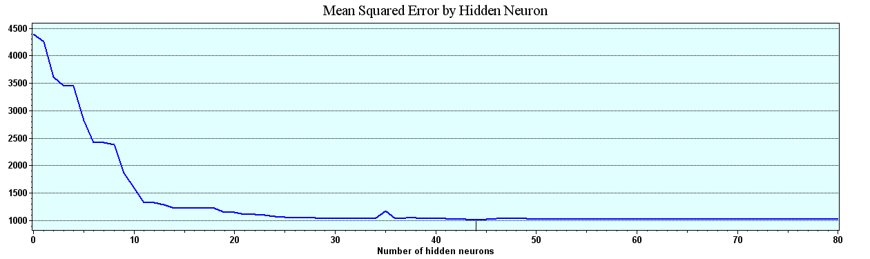
Figure 35. Loveland, Final Model, Mean Squared Error.
The following charts are the results of the RMSE calculations for both Drake and Loveland measuring stations for this final model.
For the Drake measuring station, the RMSE started at 47.75 and declined to a low of 44.64 by the addition of the 80th hidden neuron.
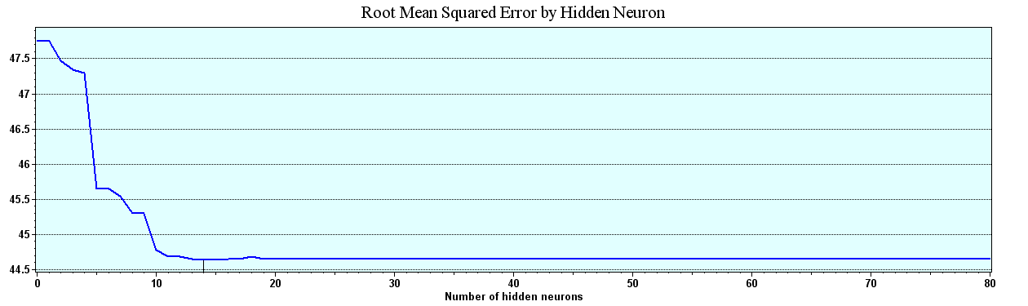
Figure 36. Drake, Final Model, RMSE.
The RMSE at the Loveland measuring station started the run at about 66 and declined to a value of 31.89
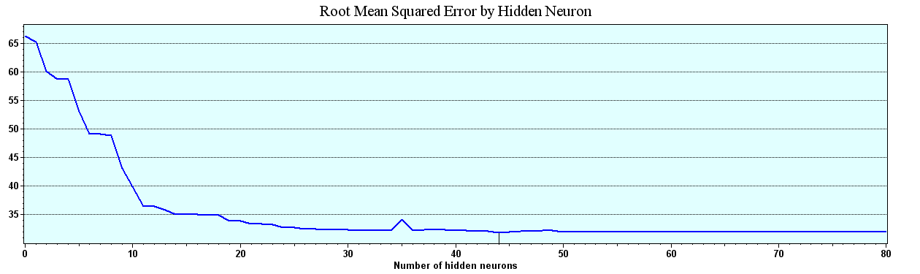
Figure 37. Loveland, Final Model, RMSE.
The Percent in Range for this final model improved exceptionally over the previous models. For the Drake measuring station, the Percent in Range with this final model started and ended at 97.3 percent. Being in excess of 95 percent, this model meets the author’s criteria of greater than 95 percent in range accuracy.
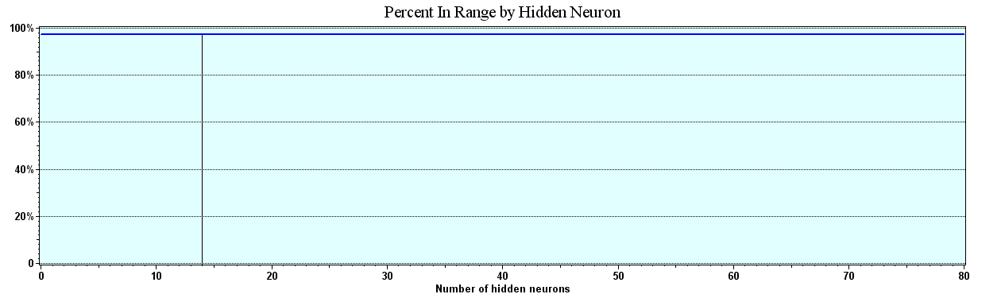
Figure 38. Drake, Final Model, Percent in Range.
The Loveland measuring station’s Percent in Range ended the run at a value of 98.1. Again, this is well above the 95 percent in range criteria set by this author.
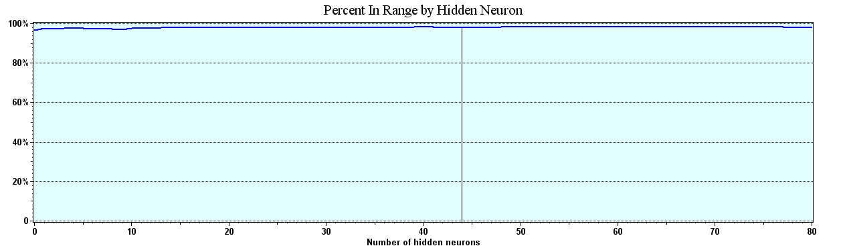
Figure 39. Loveland, Final Model, Percent in Range.

Multi-linear Regression Model
The following Multi linear regression models were created and provided by Dr. Kadar Mazouz of Florida Atlantic University (Mazouz, 2006).
A stepwise multi-linear regression model was generated for both data sets, Drake (Appendix A) and Loveland (Appendix B). Being a multiphase process, it stopped after the seventh model. For the Drake measuring station, it gave an R-square of .849, which is less than the .9091 R-square the NN Model generated for the Drake Data sets.
For the Loveland, the stepwise Multi-linear regression model was generated in eight iterations. It r an R-square of .803, which is less than the .9671 R-square generated for the Loveland data using NNs.
A summary of the statistical measures of these models is as follows:
Table 2
Summary of Statistical Results

Chapter 5: Summary and Conclusions

Summary

In this dissertation, a daily rainfall-runoff model for two flow-measuring stations, Drake and Loveland, on the Big Thompson River in Colorado, was developed using a Ward System NN program called the NeuralShell Predictor. The study attempts to demonstrate the feasibility of using a commercially available NN to accurately predict day-to-day normal flows of a river and to predict extreme flow conditions commonly called flood events. In developing this model, the following topics were addressed: (a) the use of a commercially available NN in the development of the daily rainfall, snowmelt, temperature-runoff process; (b) the evaluation of the reliability of future predictions for this NN program; and (c) the comparison of results of the to a Linear Multiple Regression model developed by Dr. Mazouz (Mazouz, 2006). In the following paragraphs, the conclusions that were drawn from this study are presented.

Conclusions
Since the early years of the twentieth century, models have been developed to forecast stream-flow. Continuous-process models that are currently available have very complex model formulations. These models are very difficult to apply because of the large number of model parameters and equations that define the components of the hydrologic cycle. The calibration of model parameters is usually accomplished by a trial and error process. As a result, the calibration accuracy of the models is very subjective and highly dependent on the user’s ability, knowledge, and understanding of the components of the model and the watershed characteristics.
The literature shows that NN methodology has been reported to provide reasonably good solutions for circumstances where there are complex systems that are (a) poorly defined and understood using mathematical equations, (b) problems that deal with noisy data or involve pattern recognition, and (c) situations where input data is incomplete and ambiguous by nature. It is because of these characteristics, that it is believed an NN could be applied to model the daily rainfall-runoff relationship. It was demonstrated that the NN rainfall-runoff models exhibit the ability to extract patterns in the training data. The testing accuracy that is compared favorably to the training accuracy, based on the ratio of standard error to standard deviation and percent prediction of peak flows, supports this belief. For the Big Thompson River, the NN provides better than 97 percent predictions within a plus or minus 100 cfm range. This is as accurate as or better than most flood prediction accuracy of any other models of which this author is aware. Based on goodness-of-fit statistics, the accuracy of this NN model compares favorably to the model accuracy of existing techniques. When comparing the results of the NN to those of the linear multiple regression analysis, it is apparent that the NN provides a clearly superior predictive capability.
The performance of a model is usually evaluated using some form of error index that is the difference between the observed and computed values of the dependent variable. The error index is called the goodness-of-fit statistics. The most commonly used goodness-of-fit statistics in the assessment of NN performance is the RMSE. RMSE is the biased standard error of estimate for the selected data set. Hence, it provides a measure of accuracy for the sample size that is used to train the network. The unbiased RMSE value can be obtained by dividing RMSE by the degrees of freedom, which is a function of number of input variables, outputs, and the network weights. The unbiased estimates of RMSE provide a better indication of future predictions for the population. The unbiased estimates of RMSE are compared to the standard deviation of daily stream flow to evaluate reliability of the NN models.
Compared to existing approaches, the NN models are relative easy to use and their calibration is more systematic. The difficulties inherent in the selection of the model form for traditional approaches are overcome in the NN methodology. The model structure in the NN methodology is defined by the number of neurons and hidden layers in the network.
The quality of the data is also a major issue for creating a flood forecasting model. The multiple-linear regression modeling required that the data be cleaned of erroneous or missing elements. To do this, every time there was a ‘no data available’ report from any of the reporting stations, the entire day’s data from all stations was eliminated. In addition, if there was a significant period of time in which the station failed to report data, then the station was eliminated from the database. For this dissertation, similarly cleaned data was used to be able to compare the NN to the multiple-linear regression model.

Limitations of this model
Although the network trained in this study can only be applied to the Big Thompson River, the guidelines in the selection of the data, training criteria, and the evaluation of the network reliability are based on statistical rules. Therefore, they are independent of the application. These guidelines can be used in any application of NNs to other rivers.
The rainfall, snowmelt, and temperature-runoff models that are developed can only be applied to these specific locations on the Big Thompson River. If there are any major changes in the watershed characteristics, such as (a) heavy urbanization, (b) deforestation, or (c) changes in stream characteristics, the models should be retrained using additional data that account for these changes.

Recommendations for Future Research
Future work is recommended in (a) the continuous training of networks without retraining, (b) the performance of the NN methodology in watersheds with other various drainage sizes, (c) watershed characteristics and climatic conditions, and (d) longer and shorter data sets.
In forecasting stream flow, it is very important to update the model without recalibrating it. This will be very advantageous where the changes in a watershed can be continuously included. This will help engineers in planning, designing, and managing future water systems.
This model was developed and tested for the Big Thompson River. The Big Thompson River is mainly driven by snowmelt with occasional heavy rains adding complexity. The NN modeling should be tested in other watersheds with (a) different size drainage areas, (b) watershed characteristics, and (c) climatic conditions.
This model was developed roughly using a seven year and ten month data history. During this time period, one extreme event was not adequately predicted. Using a longer training period would provide more extreme data that could improve the flood prediction capability of this model.
This model was developed using incomplete data. There are, from the various climatic data stations, periods of days, weeks and in the case of one climatic data station, months of no data. This was removed or cleaned. An analysis of sensitivity of the model prediction accuracy to incomplete data sets and the sensitivity to the input variables would be very helpful in modeling runoff in watersheds where data are limited, corrupted, or missing.
In this study, only one type of NN was used, a commercially produced and available program from Ward Systems Group. As discussed in Chapter 2, there are many types of NN paradigms that could be potentially used in classification problems to determine the probability distributions of random variables. An NN’s ability to recognize patterns in noisy, ambiguous, incomplete data and to generalize the patterns in complex systems makes this method a powerful tool for water resources engineers. This study demonstrates that a person with little computer expertise, no hydrologic expertise, and no programming expertise can use and apply NNs to stream flow prediction. NNs have already been applied to other water resource problems such as screening of (a) groundwater reclamation, (b) rainfall forecasting, and (c) limnology. Since solutions to most of the problems in water resources are accomplished by collecting and evaluating data and most of the applications are ambiguous and complex in nature, NNs represent a powerful tool to address these problems. The areas of (a) sediment transport, (b) bridge scour analysis, (c) modeling non-point pollution in urban areas, (d) flood frequency, and (e) flood routing analysis are examples of where NNs can be employed.
Additional work is also needed in forecasting unforeseen events such as dam failure and aberrant weather patterns such as the one that precipitated the disastrous 1976 flood on the Big Thompson River.
In this model, the large number of small changes tend to overwhelm the key peak data. Future research should be undertaken to develop methods that emphasize the reduction of error in rare but critical peak flow events.
In line with this further research, an analysis of the effect of smoothing algorithms on peak data might improve the peak flow accuracy. It is possible that a two model system would serve to more accurately predict peak flows.

APPENDIX A

MULTI-LINEAR REGRESSION, BIG THOMPSON RIVER

DRAKE MEASURING STATION

Table 3
Drake, Model Summary (i)
Model | R | R Square | Adjusted R Square | Std. Error of the Estimate
1 | .916(a) | .838 | .838 | 29.0311
2 | .918(b) | .842 | .842 | 28.7095
3 | .918(c) | .843 | .843 | 28.6109
4 | .919(d) | .845 | .845 | 28.4290
5 | .920(e) | .846 | .845 | 28.3747
6 | .920(f) | .847 | .846 | 28.3096
7 | .921(g) | .849 | .848 | 28.1527
(a) Predictors: (Constant), Preflow
(b) Predictors: (Constant), Preflow, Tobs3
(c) Predictors: (Constant), Preflow, Tobs3, Prcp2
(d) Predictors: (Constant), Preflow, Tobs3, Prcp2, Prcp4
(e) Predictors: (Constant), Preflow, Tobs3, Prcp2, Prcp4, Tmax3
(f) Predictors: (Constant), Preflow, Tobs3, Prcp2, Prcp4, Tmax3, Prcp5
(g) Predictors: (Constant), Preflow, Tobs3, Prcp2, Prcp4, Tmax3, Prcp5, Snow5
(h) Dependent Variable: OUTPUT

Table 4
Drake Coefficients (a)
Model |  | Unstandardized Coefficients |  | Standardized Coefficients | t | Sig.
 |  | B | Std. Error | Beta
1 | (Constant) | 6.333 | 1.328 |  | 4.769 | .000
 | Preflow | .929 | .012 | .916 | 75.372 | .000
2 | (Constant) | -9.700 | 3.425 |  | -2.832 | .005
 | Preflow | .894 | .014 | .881 | 63.773 | .000
 | Tobs3 | .332 | .065 | .070 | 5.069 | .000
3 | (Constant) | -11.043 | 3.444 |  | -3.207 | .001
 | Preflow | .885 | .014 | .872 | 61.842 | .000
 | Tobs3 | .356 | .066 | .075 | 5.410 | .000
 | Prcp2 | 17.435 | 5.958 | .036 | 2.926 | .003
4 | (Constant) | -10.385 | 3.426 |  | -3.031 | .002
 | Preflow | .895 | .014 | .881 | 62.015 | .000
 | Tobs3 | .345 | .065 | .073 | 5.281 | .000
 | Prcp2 | 24.099 | 6.164 | .050 | 3.910 | .000
 | Prcp4 | -28.397 | 7.322 | -.049 | -3.878 | .000
5 | (Constant) | -3.959 | 4.433 |  | -.893 | .372
 | Preflow | .894 | .014 | .881 | 62.128 | .000
 | Tobs3 | .697 | .167 | .147 | 4.161 | .000
 | Prcp2 | 24.630 | 6.157 | .051 | 4.001 | .000
 | Prcp4 | -28.838 | 7.310 | -.050 | -3.945 | .000
 | Tmax3 | -.388 | .170 | -.079 | -2.278 | .023
6 | (Constant) | -.853 | 4.600 |  | -.186 | .853
 | Preflow | .899 | .014 | .886 | 62.083 | .000
 | Tobs3 | .720 | .167 | .152 | 4.305 | .000
 | Prcp2 | 25.551 | 6.154 | .053 | 4.152 | .000
 | Prcp4 | -21.211 | 7.928 | -.037 | -2.676 | .008
 | Tmax3 | -.451 | .172 | -.091 | -2.622 | .009
 | Prcp5 | -24.342 | 9.916 | -.033 | -2.455 | .014
7 | (Constant) | -3.417 | 4.629 |  | -.738 | .460
 | Preflow | .909 | .015 | .895 | 62.064 | .000
 | Tobs3 | .711 | .166 | .150 | 4.276 | .000
 | Prcp2 | 26.551 | 6.126 | .055 | 4.334 | .000
 | Prcp4 | -19.564 | 7.897 | -.034 | -2.477 | .013
 | Tmax3 | -.416 | .171 | -.084 | -2.427 | .015
 | Prcp5 | -60.401 | 13.991 | -.083 | -4.317 | .000
 | Snow5 | 4.335 | 1.193 | .066 | 3.633 | .000
- Dependent Variable: OUTPUT

Actually, the independent variables that contributed the most to the variability of the output are Preflow, TOBS3, Prcp2, Prcp4, Prcp5, and Snow5. Their corresponding coefficients in the model are:
Table 5
Drake, Coefficients Summary

.909 for Preflow
.711 for Tobs3
26.551 for Prcp2
-19.564 for Prcp4
-.416 for Tmax3
-60.401 for Prcp5
4.335 for Snow5

APPENDIX B

MULTI-LINEAR REGRESSION MODEL: THE BIG THOMPSON RIVER
LOVELAND MEASURING STATION

Table 6
Loveland, Summary (i)
Model | R | R Square | Adjusted R Square | Std. Error of the Estimate
1 | .881(a) | .777 | .776 | 22.06113
2 | .891(b) | .793 | .793 | 21.23824
3 | .892(c) | .796 | .796 | 21.09537
4 | .893(d) | .798 | .797 | 21.01388
5 | .894(e) | .799 | .798 | 20.95246
6 | .895(f) | .801 | .800 | 20.85033
7 | .896(g) | .803 | .801 | 20.80284
8 | .896(h) | .803 | .802 | 20.76851
(a) Predictors: (Constant), Preflow
(b) Predictors: (Constant), Preflow, OFEstes
(c) Predictors: (Constant), Preflow, OFEstes, Prcp3
(d) Predictors: (Constant), Preflow, OFEstes, Prcp3, Prcp_A
(e) Predictors: (Constant), Preflow, OFEstes, Prcp3, Prcp_A, Tmin3
(f) Predictors: (Constant), Preflow, OFEstes, Prcp3, Prcp_A, Tmin3, Tmax1
(g) Predictors: (Constant), Preflow, OFEstes, Prcp3, Prcp_A, Tmin3, Tmax1, Snow_A
(h) Predictors: (Constant), Preflow, OFEstes, Prcp3, Prcp_A, Tmin3, Tmax1, Snow_A, Tobs_A
(i) Dependent Variable: LvdFlow

Table 7
Loveland, Coefficients (a)
Mod |  | Unstandard-  ized  Coeffic-  ients |  | Standard-ized Coeffic-ients | t | Sig.
 |  | B | Std. Error | Beta
1 | (Constant) | 3.773 | .895 |  | 4.214 | .000
 | Preflow | .893 | .016 | .881 | 57.556 | .000
2 | (Constant) | -3.453 | 1.195 |  | -2.890 | .004
 | Preflow | .796 | .019 | .785 | 42.727 | .000
 | OFEstes | .158 | .018 | .161 | 8.734 | .000
3 | (Constant) | -3.392 | 1.187 |  | -2.858 | .004
 | Preflow | .798 | .019 | .788 | 43.134 | .000
 | OFEstes | .145 | .018 | .147 | 7.907 | .000
 | Prcp3 | 17.644 | 4.726 | .056 | 3.733 | .000
4 | (Constant) | -3.896 | 1.195 |  | -3.261 | .001
 | Preflow | .799 | .018 | .789 | 43.329 | .000
 | OFEstes | .142 | .018 | .145 | 7.816 | .000
 | Prcp3 | 14.510 | 4.830 | .046 | 3.004 | .003
 | Prcp_A | 21.586 | 7.452 | .044 | 2.897 | .004
5 | (Constant) | 1.592 | 2.449 |  | .650 | .516
 | Preflow | .802 | .018 | .791 | 43.531 | .000
 | OFEstes | .186 | .025 | .190 | 7.466 | .000
 | Prcp3 | 14.639 | 4.817 | .046 | 3.039 | .002
 | Prcp_A | 19.897 | 7.459 | .040 | 2.667 | .008
 | Tmin3 | -.209 | .082 | -.059 | -2.565 | .010
6 | (Constant) | -5.482 | 3.285 |  | -1.669 | .095
 | Preflow | .804 | .018 | .794 | 43.842 | .000
 | OFEstes | .191 | .025 | .194 | 7.670 | .000
 | Prcp3 | 15.157 | 4.796 | .048 | 3.160 | .002
 | Prcp_A | 28.012 | 7.841 | .056 | 3.572 | .000
 | Tmin3 | -.499 | .121 | -.141 | -4.112 | .000
 | Tmax1 | .290 | .090 | .091 | 3.212 | .001
7 | (Constant) | -4.649 | 3.297 |  | -1.410 | .159
 | Preflow | .804 | .018 | .794 | 43.945 | .000
 | OFEstes | .182 | .025 | .185 | 7.228 | .000
 | Prcp3 | 14.747 | 4.788 | .047 | 3.080 | .002
 | Prcp_A | 44.983 | 10.734 | .091 | 4.191 | .000
 | Tmin3 | -.492 | .121 | -.139 | -4.064 | .000
 | Tmax1 | .281 | .090 | .089 | 3.117 | .002
 | Snow_A | -2.197 | .951 | -.048 | -2.309 | .021
8 | (Constant) | -5.782 | 3.338 |  | -1.732 | .084
 | Preflow | .802 | .018 | .791 | 43.808 | .000
 | OFEstes | .188 | .025 | .191 | 7.434 | .000
 | Prcp3 | 14.625 | 4.781 | .046 | 3.059 | .002
 | Prcp_A | 44.657 | 10.717 | .090 | 4.167 | .000
 | Tmin3 | -.410 | .127 | -.116 | -3.224 | .001
 | Tmax1 | .369 | .100 | .116 | 3.695 | .000
 | Snow_A | -2.401 | .955 | -.053 | -2.514 | .012
 | Tobs_A | -.231 | .114 | -.061 | -2.033 | .042
(a) Dependent Variable: LvdFlow

Actually, the independent variables that contributed the most to the variability of the output are Preflow, OFestes, Prcp3, PrcpA, Tmin3, Snow A, Tobs A. Their corresponding coefficients in the model are:
Table 8
Loveland, Coefficients Summary

Preflow | .802
OFEstes | .188
Prcp3 | 14.625
Prcp_A | 44.657
Tmin3 | -.410
Tmax1 | .369
Snow_A | -2.401
Tobs_A | -.231

Data Sources

The data sources for this dissertation are:
The National Climatic Data Center. http://lwf.ncdc.noaa.gov/oa/ncdc.html
U.S. Department of Interior, Dams, projects and power plants, Bureau of Reclamation. http://www.usbr.gov/dataweb/html/cbt.html#general
Federal Emergency Management Agency, Floodplain Information.
http://www.fema.gov
Ward Systems Group, Inc.
http://www.wardsystems.com
Northern Colorado Conservation District

http://www.ncwcd.org/project_features/boundary_map.asp

References

